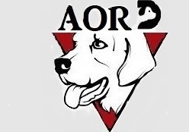 ADOPTION OF RESCUED DOGS

Website Design & Development

BSE 21 BFT 3

Presented by LOVENA UJOODHA

2110_22856

KESHINI SESUNGKUR

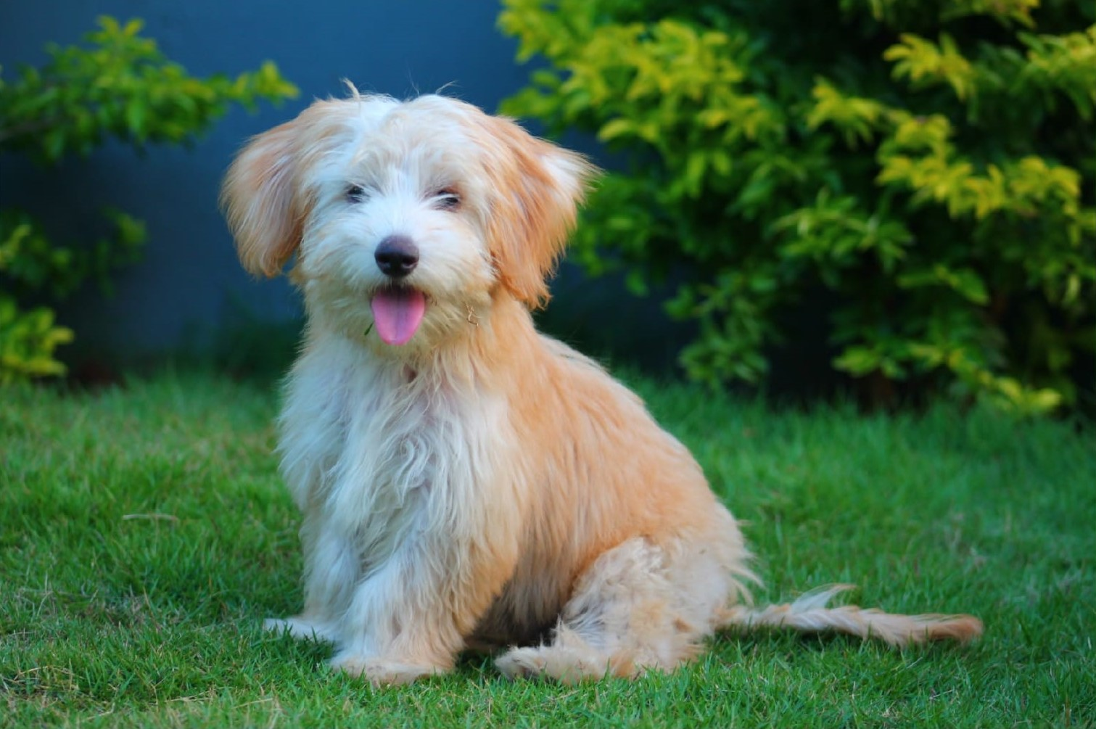 2110_22847

Have you seen a dog in need?

adoption

of

rescued

dogs

|  |
| --- |
|  |

Table Of Content

Summary 4

Introduction 5

Purpose or goals of the website 6

Functionalities of the website 6

Target Audience 6

SITEMAP 7

WIREFRAME 8

COLOR CHART 9

GANTT CHART 10

WEB HOSTING (000webhost.com) 11

WEB PERFORMANCE REPORT (dareboost.com) 12

BROWSER COMPATIBILITY (crossbrowsertesting.com) 12

ACCESSIBILITY CHECKER (webaccessibility.com) 32

# **Summary**

This report consists of an introduction of the project work which is “AORD”. It describes the purpose of the website and its target audience as well as the functionalities in dept. A sitemap is produced to provide details about the website and a wireframe to give an idea of the layout of the website. The color chart shows all the colors that have been used in designing the website. Moreover, a Gantt chart is provided that illustrate the time taken in building the website.

Additionally, testing is done such as web performance report is made so that the client gets an idea about the loading of the webpages. Accessibility Check is carried out to make sure people with disabilities can easily access the website and its resources. Also, the responsiveness of each html page is shown in the report.

# **Introduction**

The website is for a shelter named AORD which stands for Adoption of Rescue Dog and has been operating since 2001. The shelter rescue stray and sick dogs who are living in a very bad condition such as suffering from skin disease, broken bone or fracture, cancer and so on. They are well equipped with their own veterinarians who look after the sick dogs. The AORD provides the dogs with all the necessary treatment they need, then afterwards the dogs are given for adoption and fostering after doing a propre checking and making sure the dog is in a good hand. The AORD shelter is located at Lalmatie, as the villages nearby have a lot of stray dogs, so it is easy for the team to step on the field and rescue those dogs.

The website contains the shelter’s logo and has around twenty-seven hyperlinks in total. In the home page the navigation consists of the following hyperlinks *Home , About Us* , Contact , Location , Gallery , Our Services\** and *search*. Moreover, a background picture of a dog with text on it. Below it there is an “ADOPTION” button link to the adoption and fostering page, then we have four buttons/hyperlinks *Adopt/Foster , Donate , Event , Policy* along with *Login form\** and *Register Form*. In addition, some contents of stray dogs with their pictures are provided to make people aware of how AORD takes good care of the rescue dogs to find them a better where will be safe and happy.

The video in the homepage is about small puppies which was dumped and found by a user who sent us a video on WhatsApp with its location. How our website differs from others? There’s a “Live Location” button on the home page which is sent to the AORD team to rescue the dogs. Additionally, it has a table indicating the opening and closing time of the shelter. Then a sum up of all the main hyperlinks along with *Complaint* and *Feedback* linksare provides at the end. However, then footer consists of the social link to AORD Instagram.

# **Purpose or goals of the website**

The aim is to change the shelter’s system of operating from a manual system to an automatic and sophisticated one to increase awareness about stray dogs. As the world today is more on the internet, it is easier to sensibilize people, that dogs have the right to live a good life and not just end up someone’s meal or dead on the street. The world should know the importance of a dog in an individual’s life as it prevents depression and anxiety by easing someone’s loneliness. By playing with a dog and being physically active, it improves health and prevents cardiovascular diseases.

# **Functionalities of the website**

It enables people to look for dogs of different breeds and adopt or foster them. This requires the individual to check the “Adoption/Fostering process” requirements and fill some online forms then the adoption procedure will proceed forward. Regarding the fostering of a dog, an individual is allowed to foster no more than a dog for around one to three weeks. The shelter often organizes charity events to raise funds so that they can provide the dogs with better care, treatment food and more. Also, people can adopt some dogs on site of the event, therefore the information about when and where the event is held is updated on the AORD website “Event” page. People can also donate things for the dogs such as dog food, blankets, and accessories by coming to the shelter. However, by using the “Live Location” button on the home page people can share stray dogs’ location so the AORD team can rescue those dogs.

# **Target Audience**

Our targeted audience varies for all age as 74% people worldwide love dogs specially kids as they have an innocent heart and care for animals, which also help children grow up more secure and active. Moreover, adults living alone or older adults as well because it provides valuable companionship for them. So, people who care about dogs and love dogs are mostly our targets.

# **SITEMA****P**

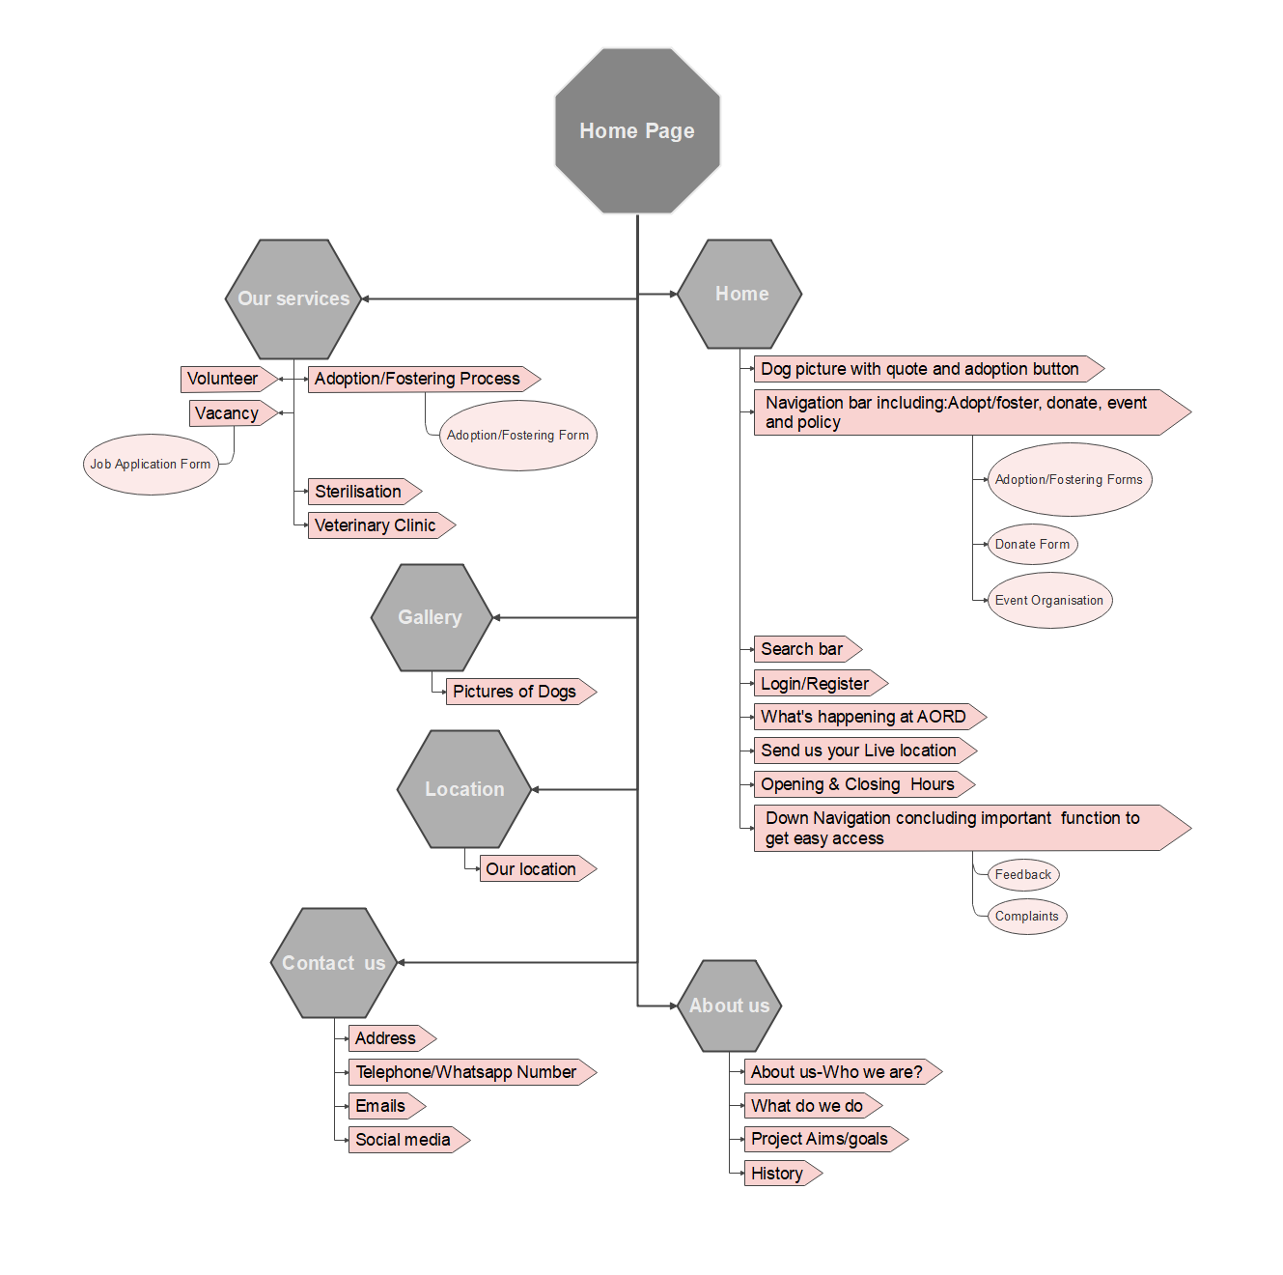

# **WIREFRAME**

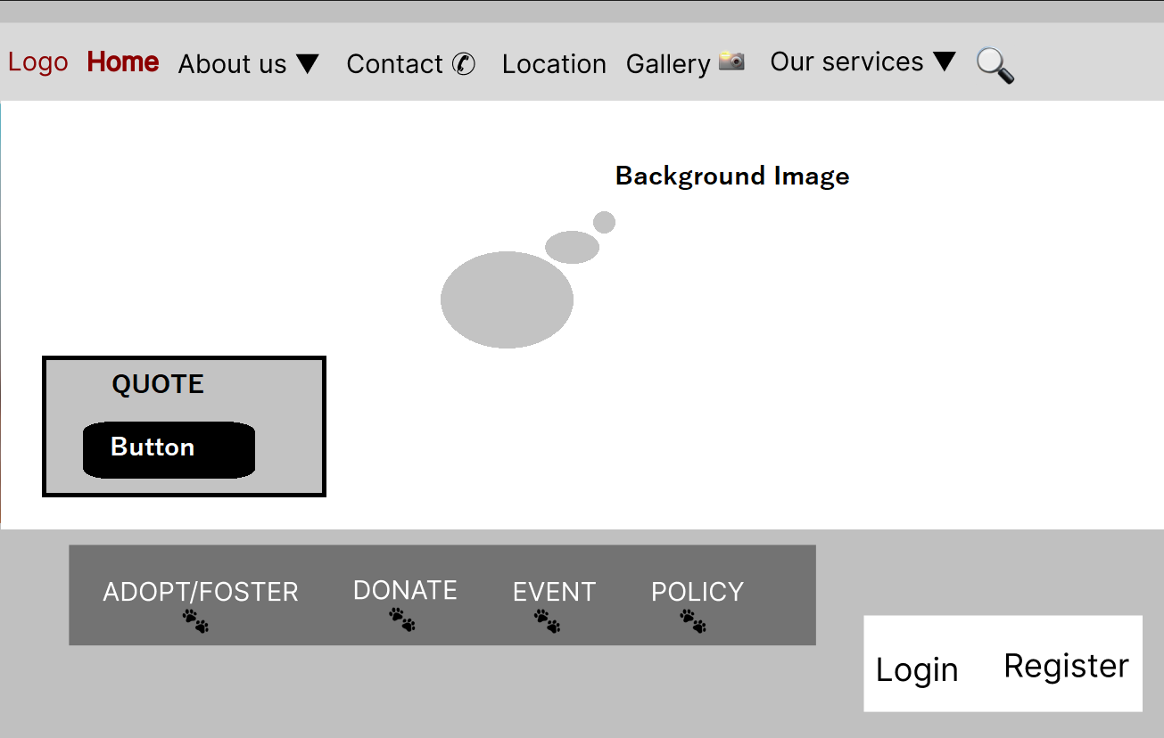

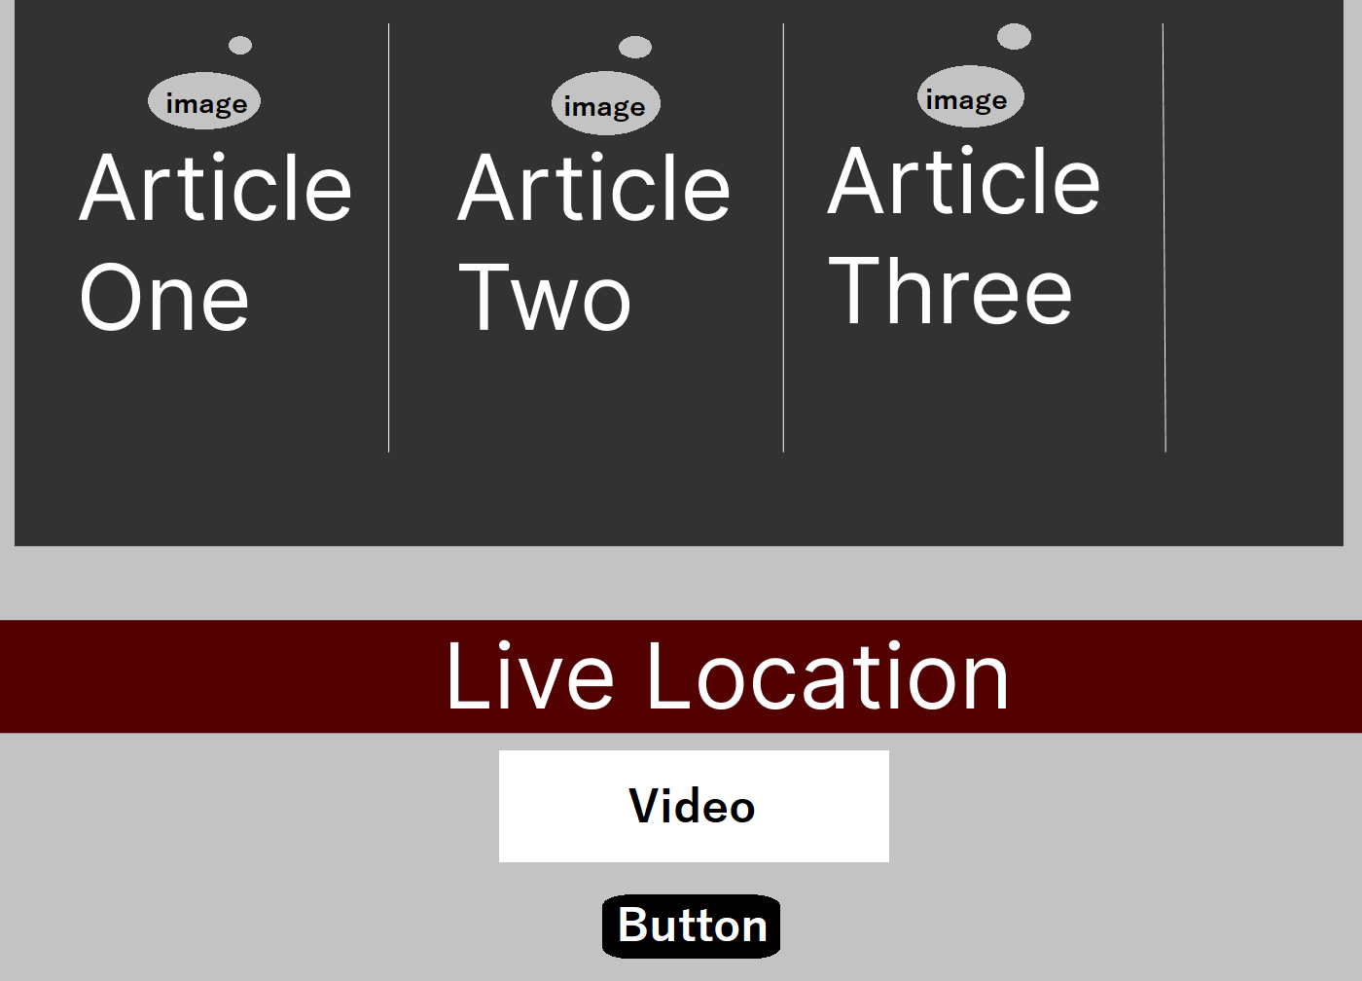

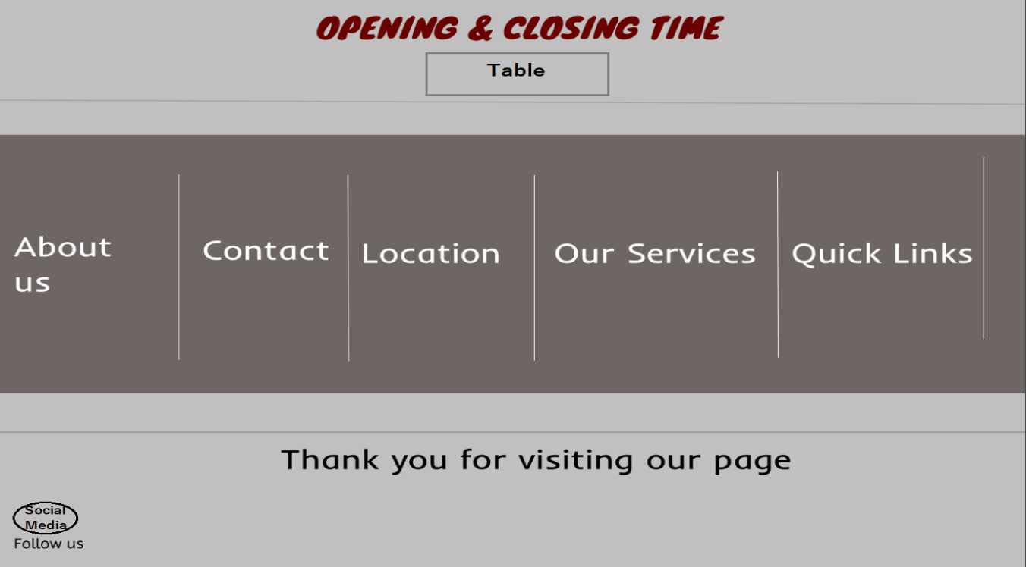

# **COLOR CHART**

# **GANTT CHART**

# **WEB HOSTING (000webhost.com)**

Address of the website: <https://aord.000webhostapp.com/>

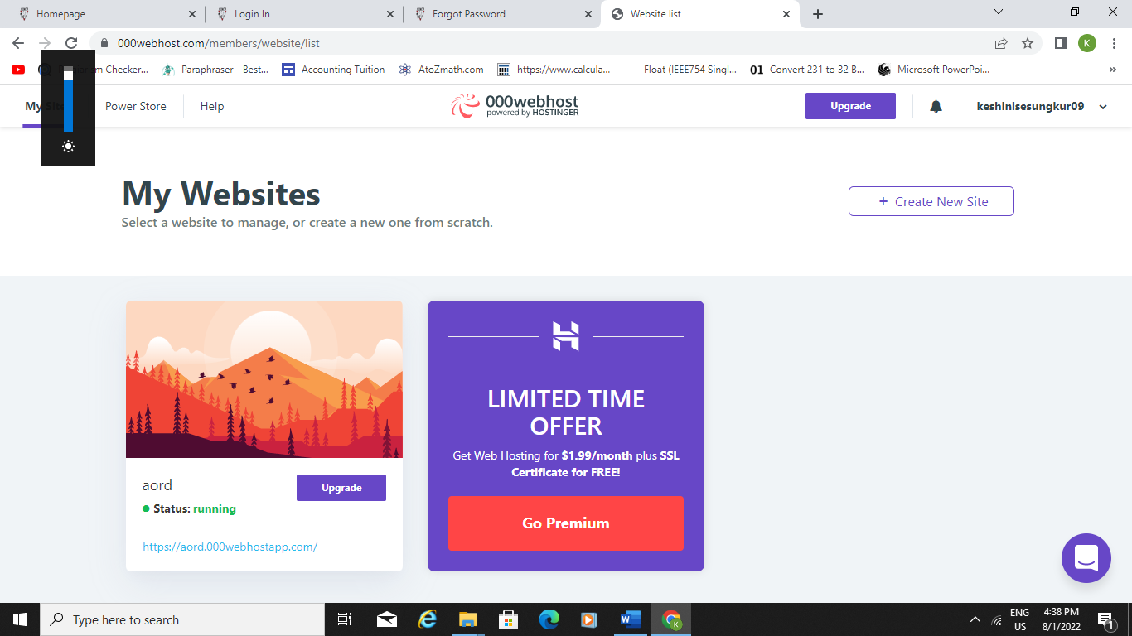

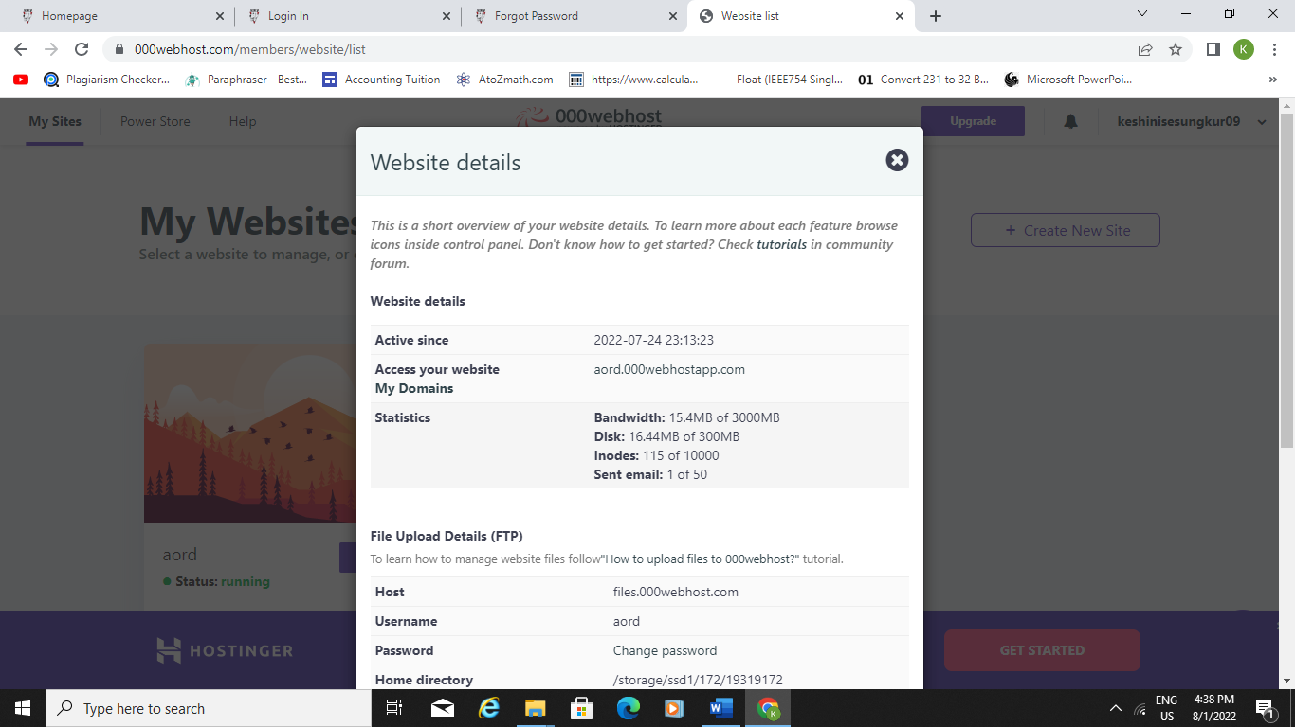

# **WEB PERFORMANCE REPORT (dareboost.com)**

Website performance is critical because often users think that the loading of the page is slow. Therefore, this report helps users to estimate the performance of the AORD website.

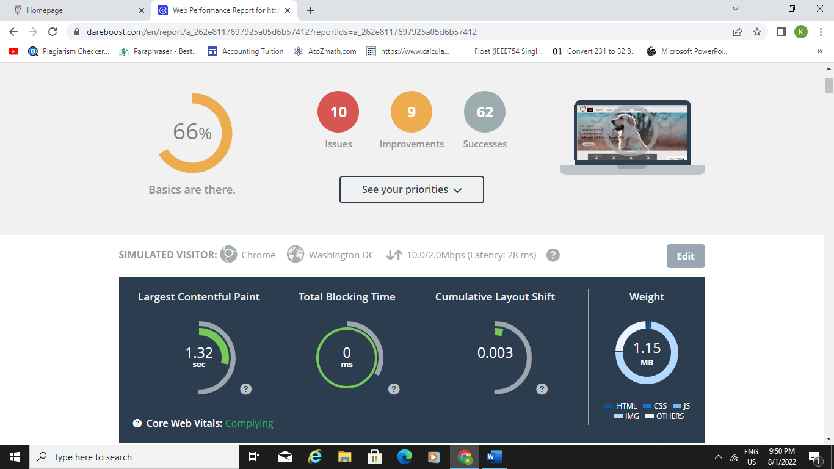

# **BROWSER COMPATIBILITY (crossbrowsertesting.com)**

**AORD WEBSITE**

**Homepage(index.html)**

Desktop

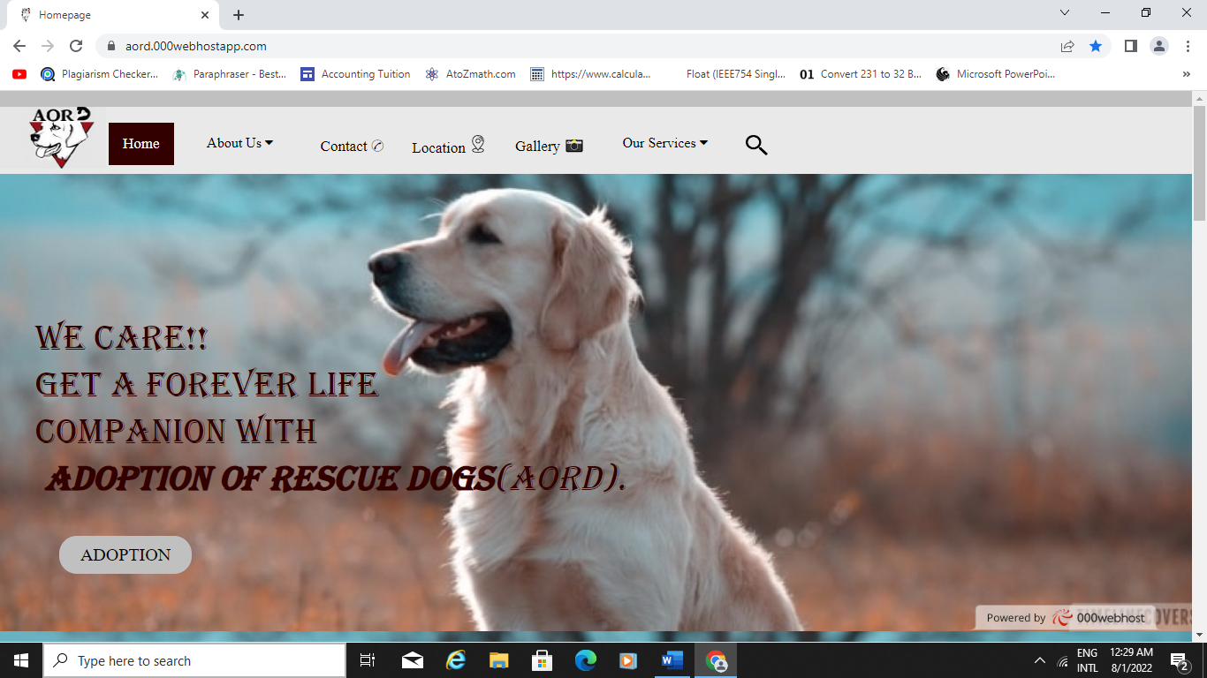

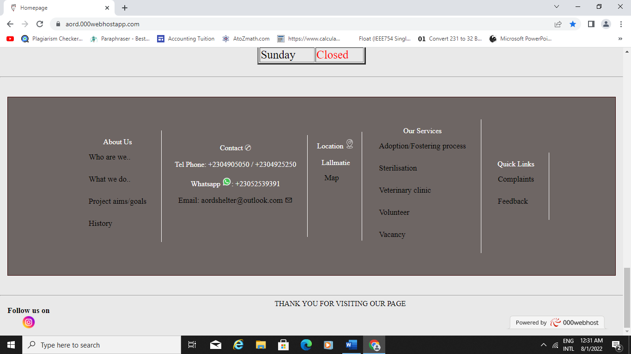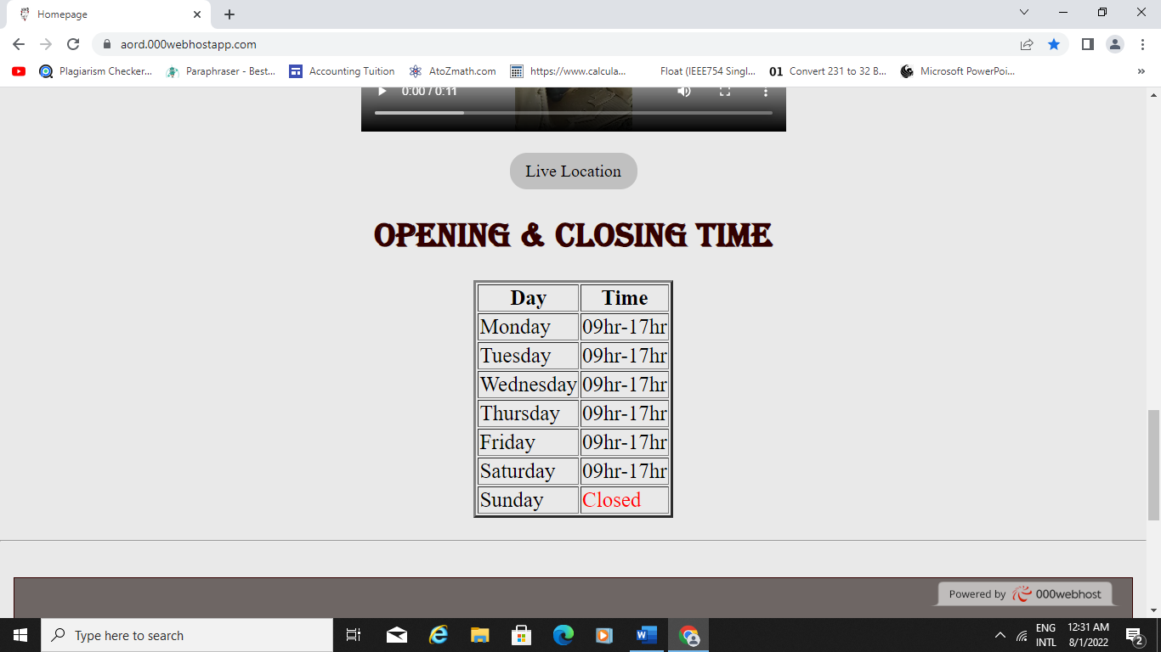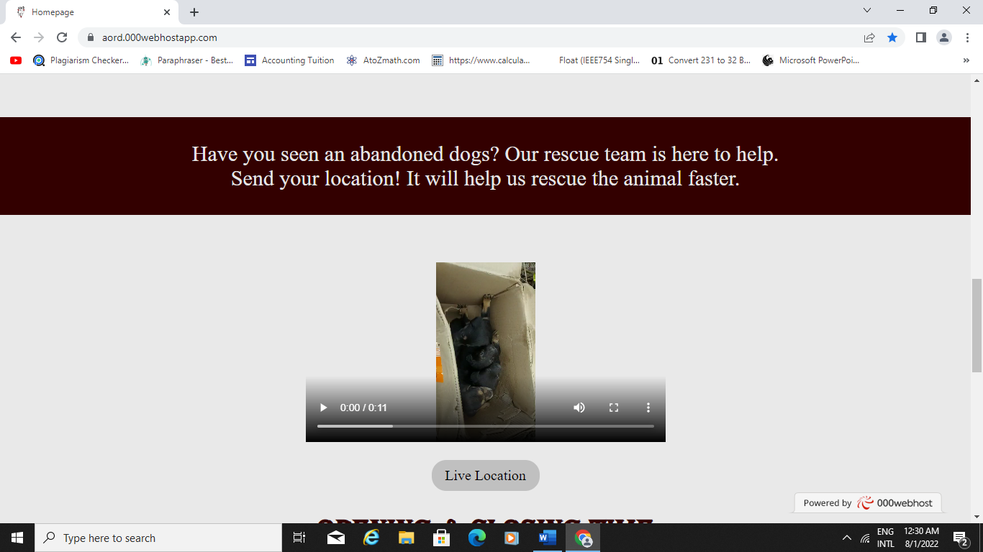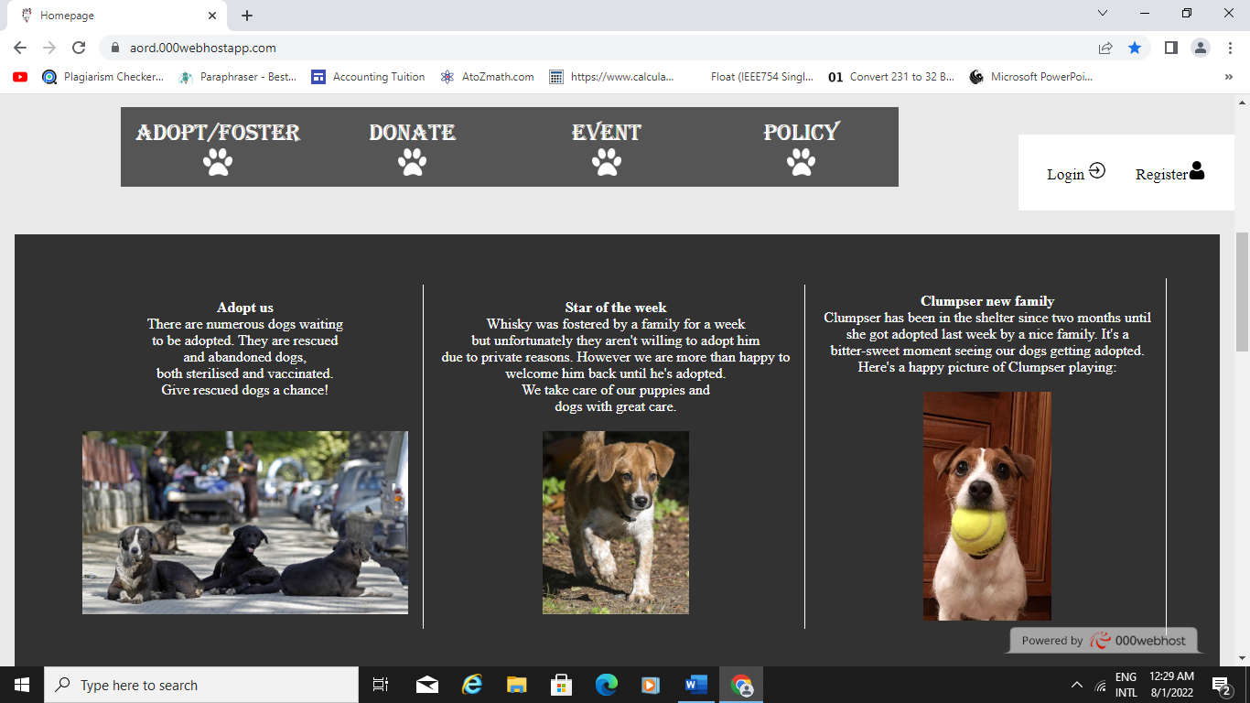

Android

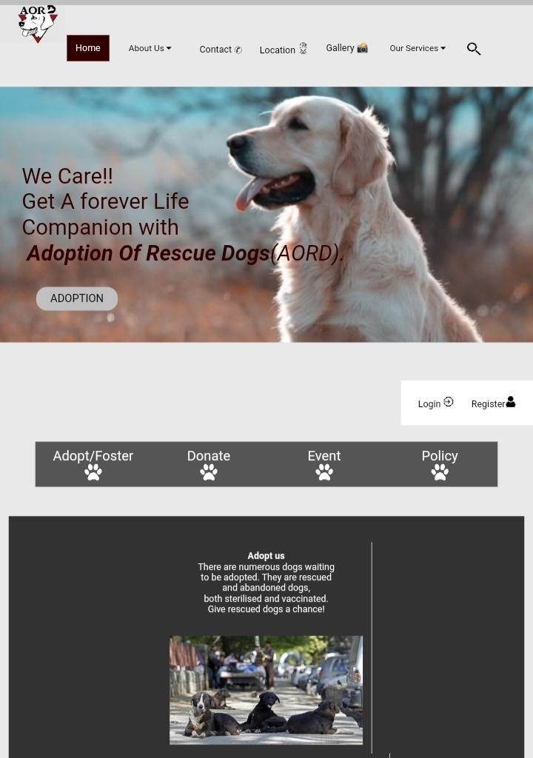 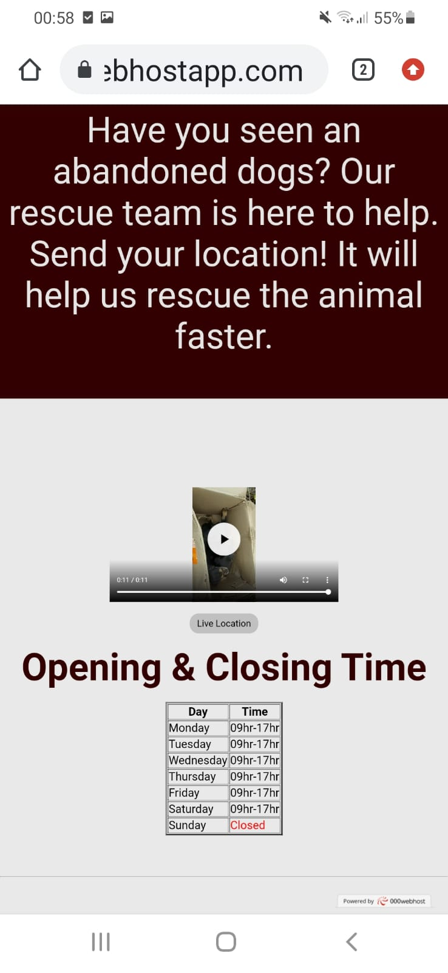

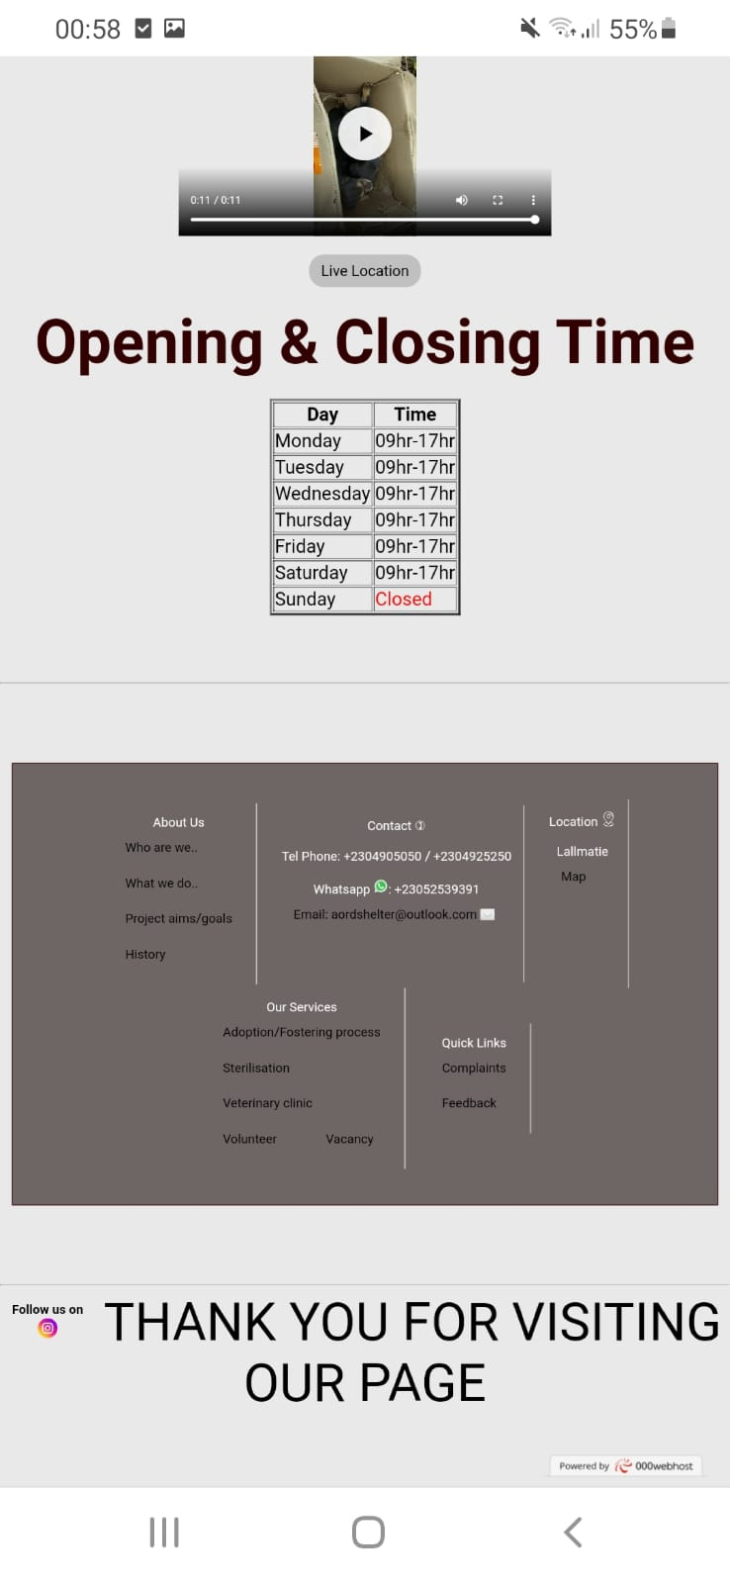

**About Us (AboutUs.html)**

Desktop

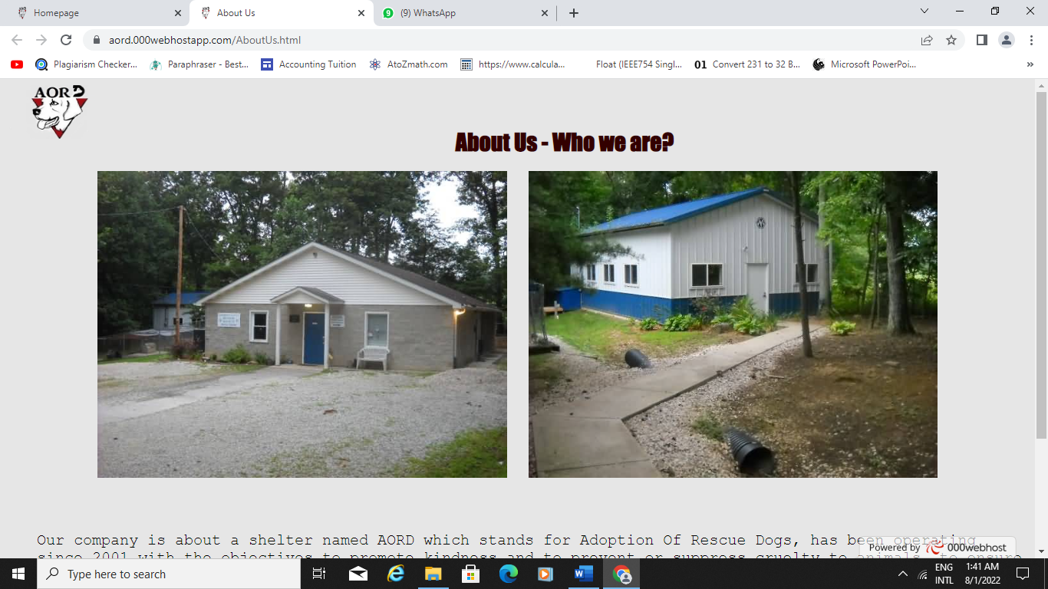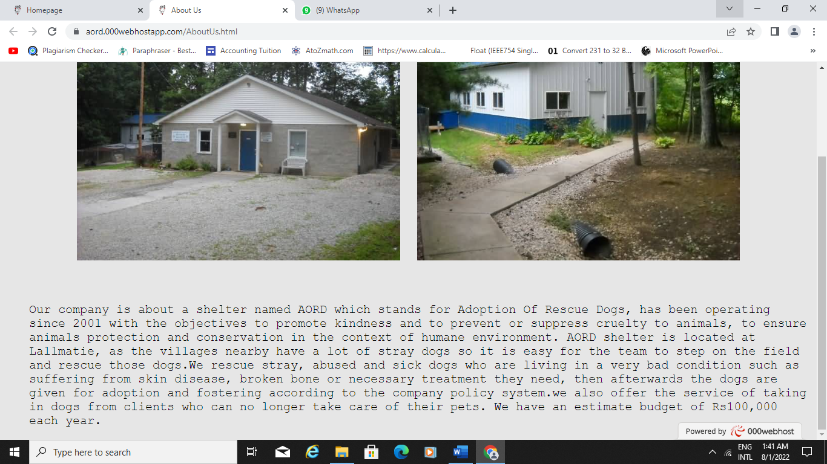

Android

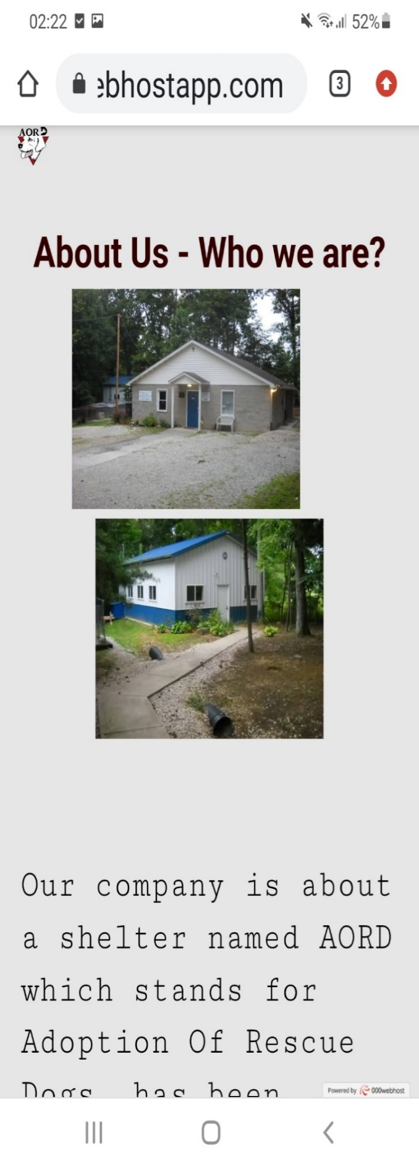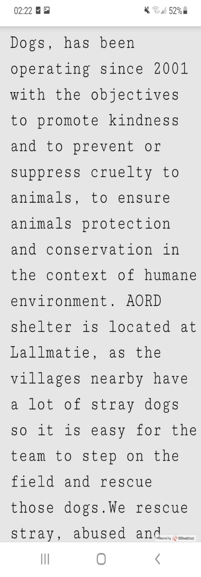

**Contact (Contact.html)**

Desktop

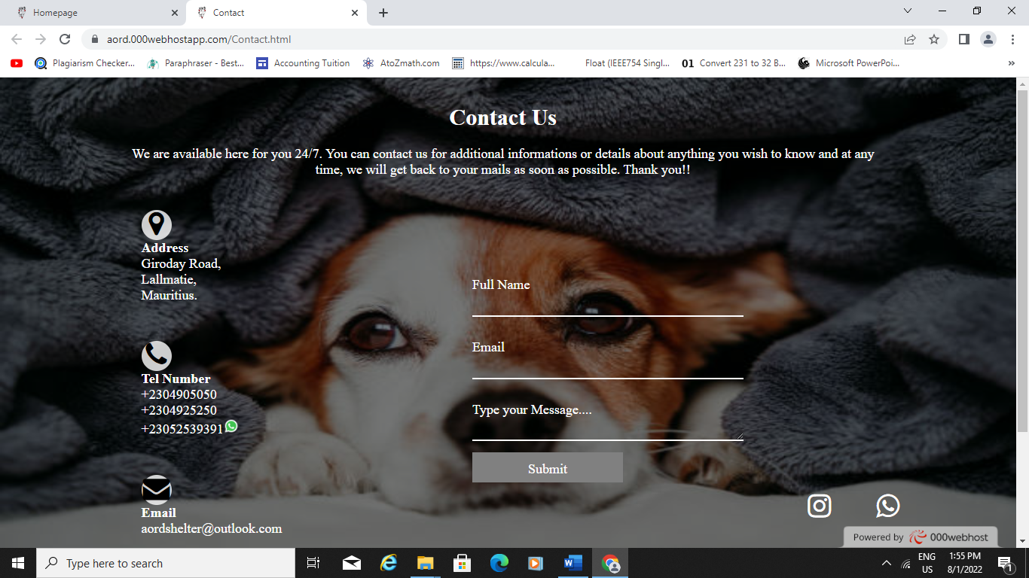

Android

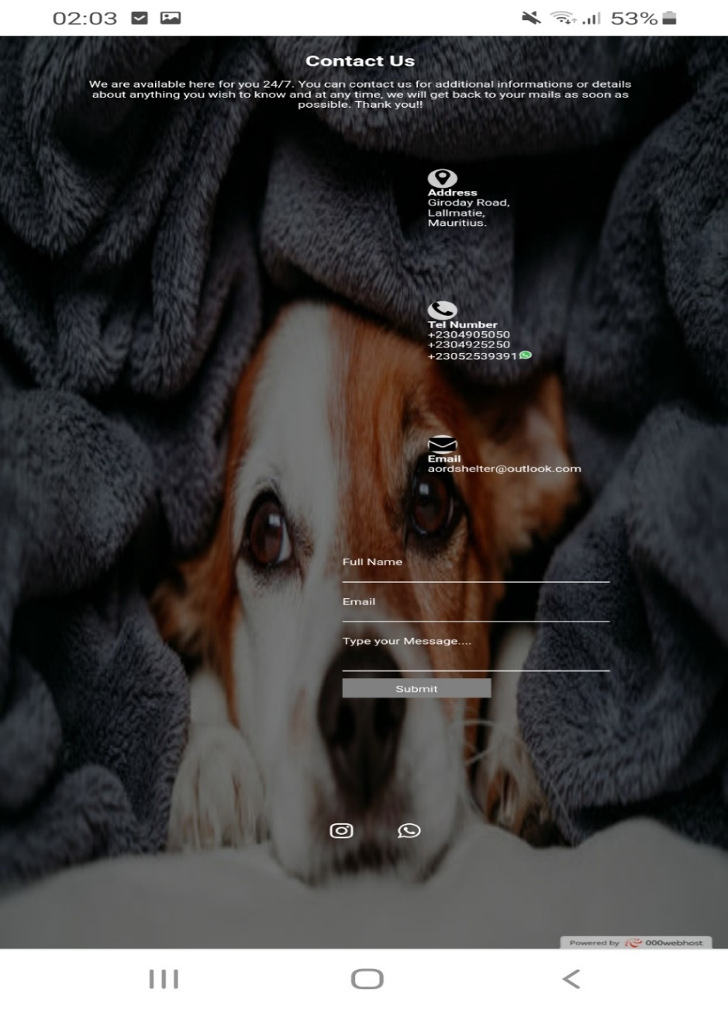

**Location (Location.html)**

Desktop

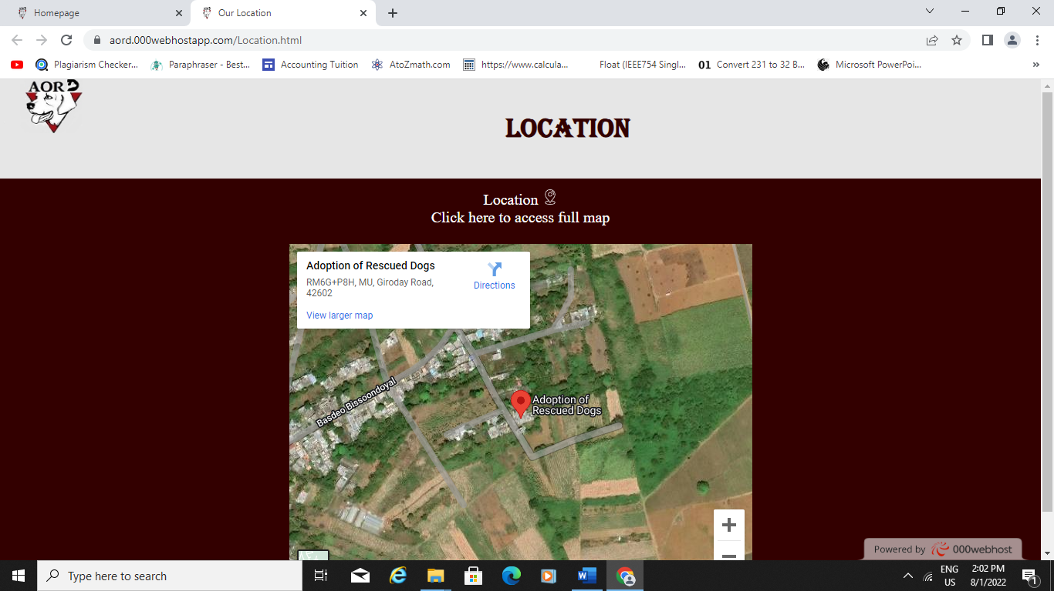

Android

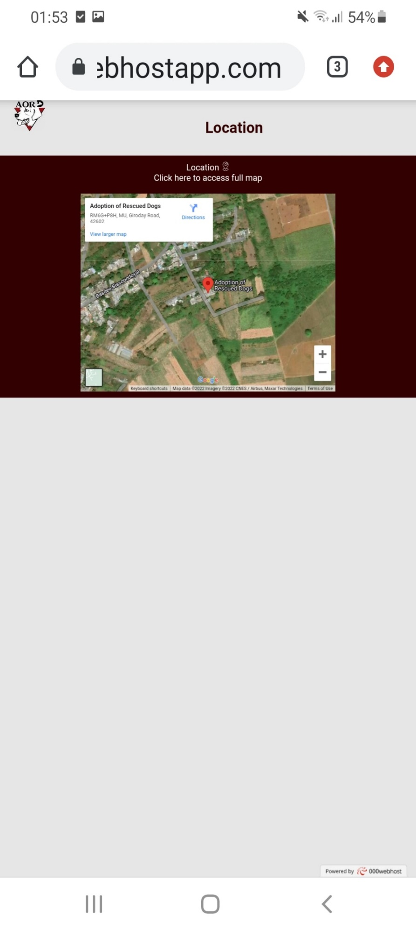

**Gallery (Gallery.html)**

Desktop

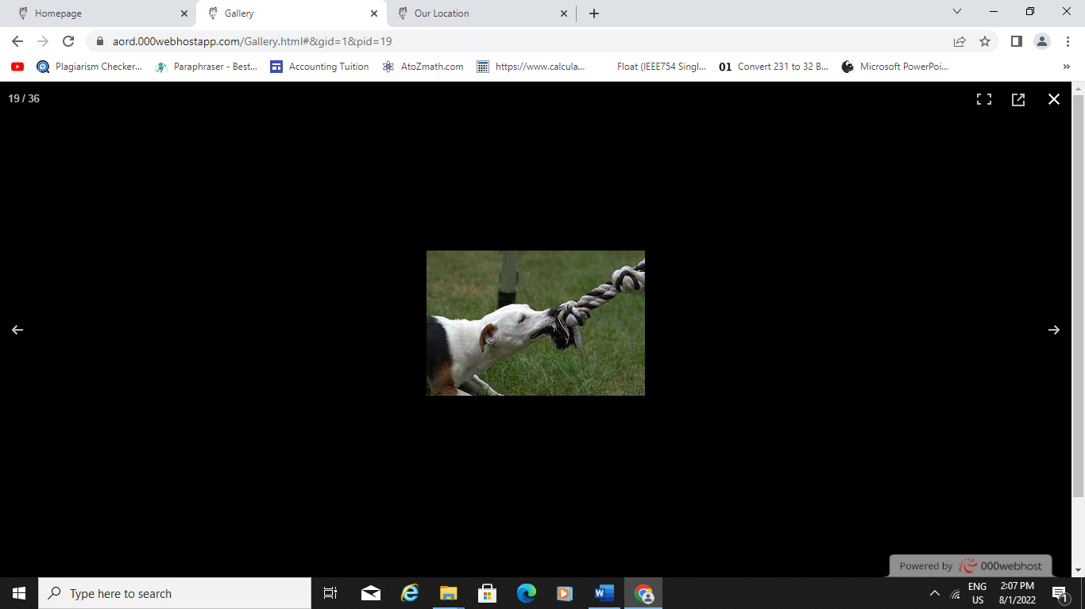

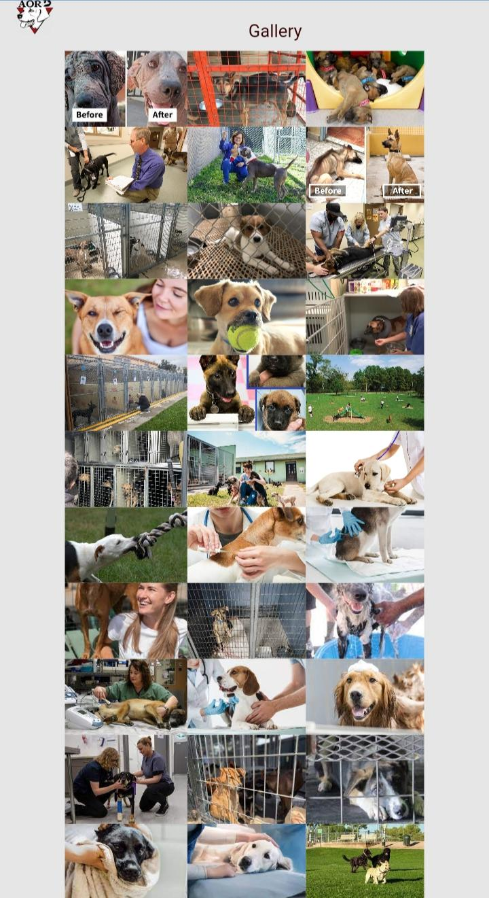Android

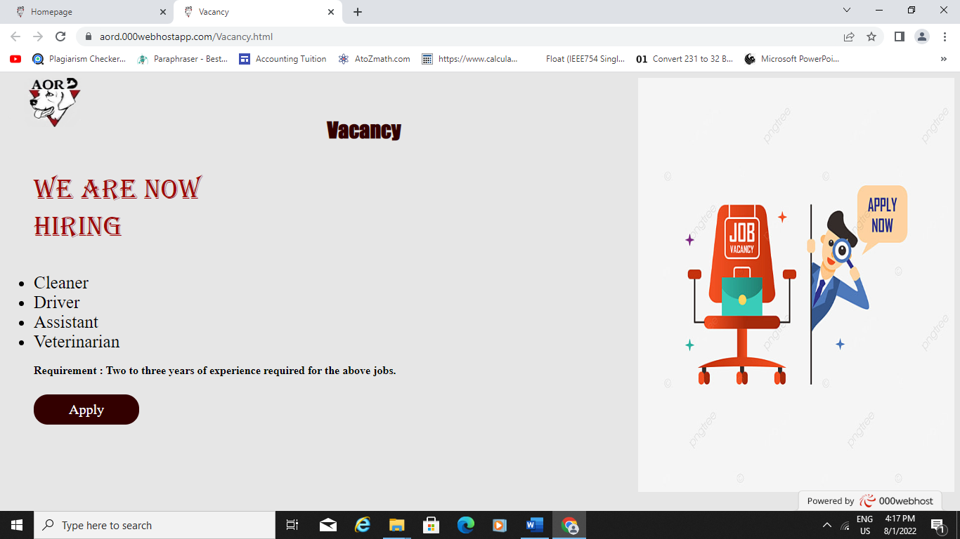**Vacancy (Vacancy.html**

Desktop

Android

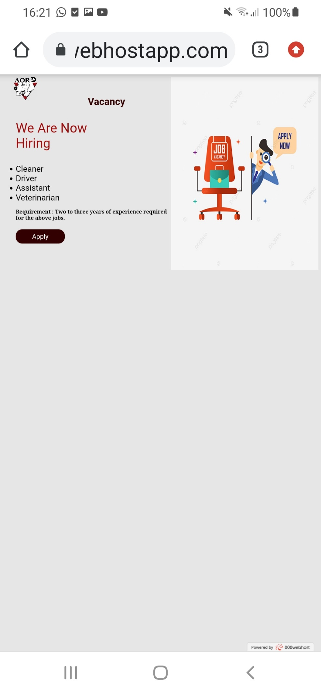

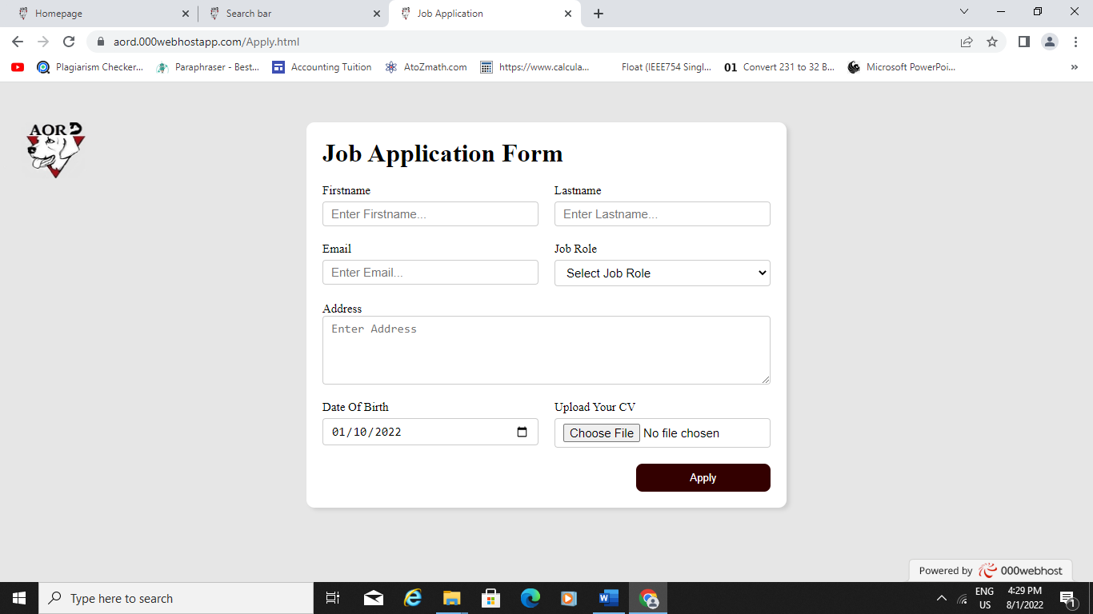**FORM- Job Application (Apply.html)**

Desktop

Android

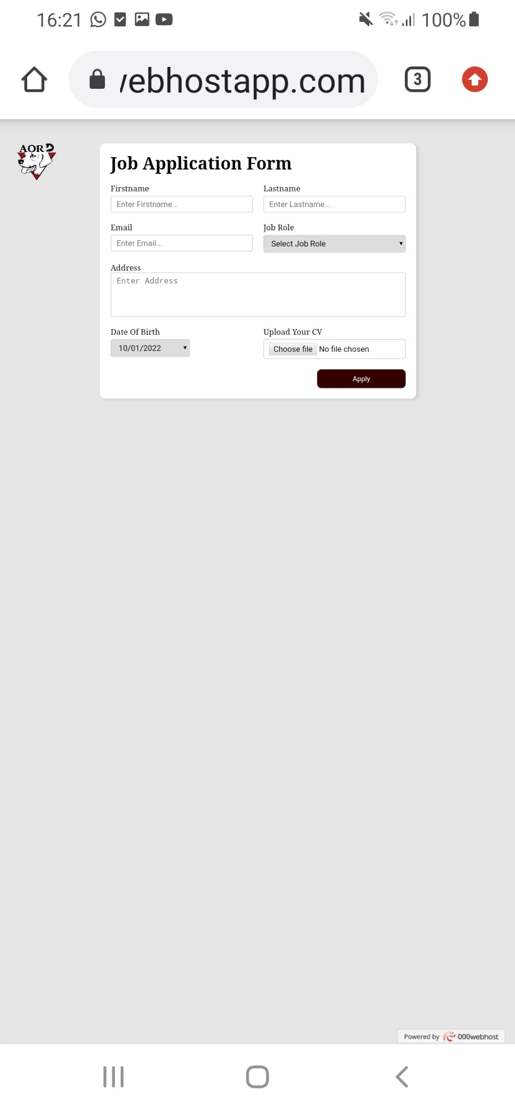

**Search Bar (Searching.html)**

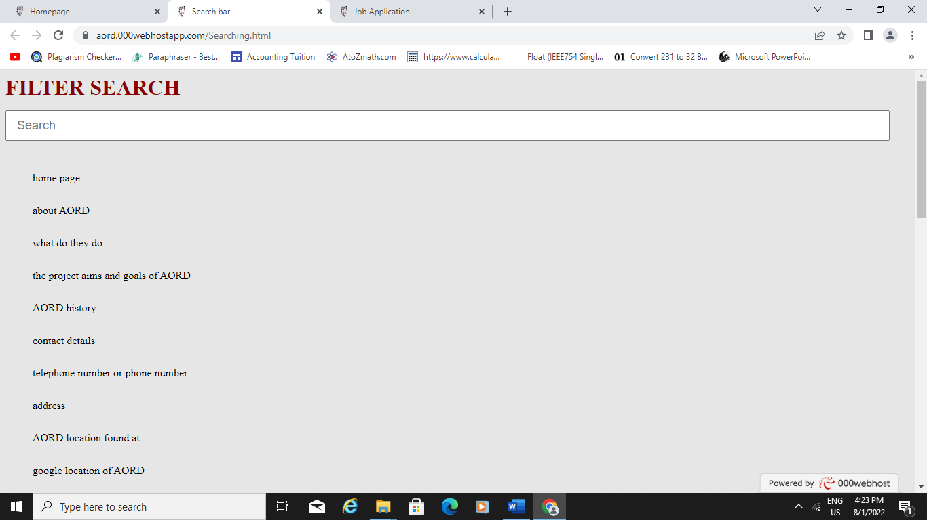Desktop

**Android**

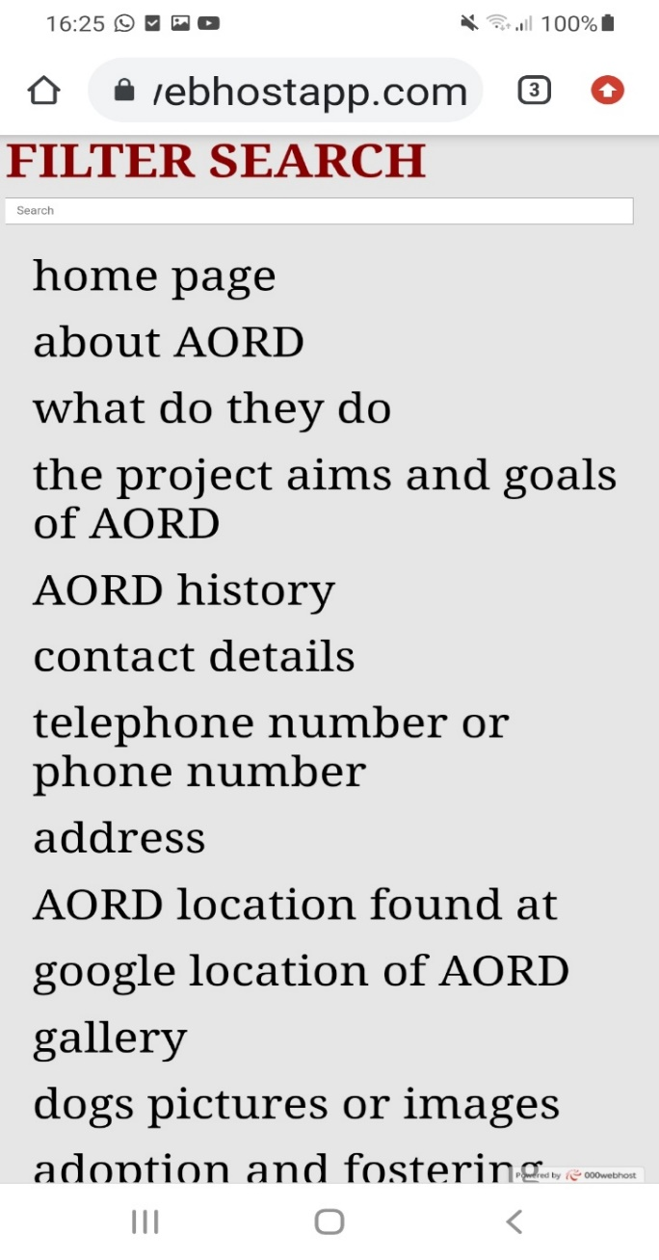

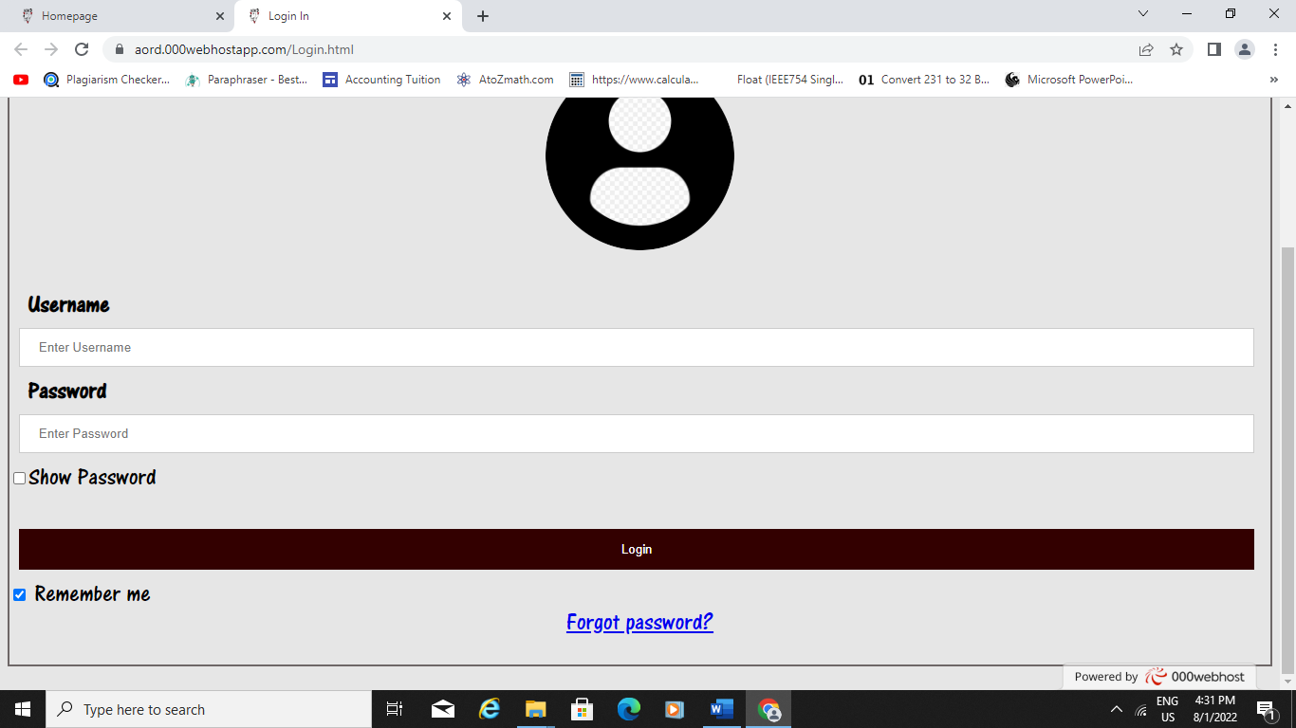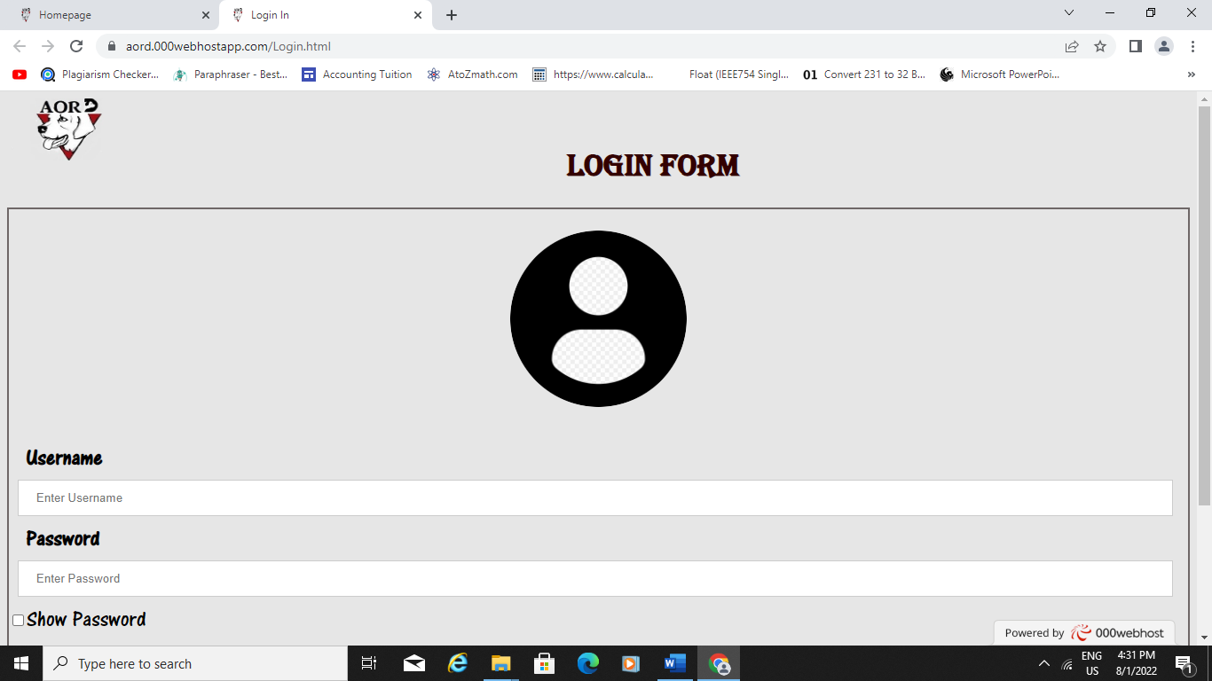**FORM- Login (Login.html)**

Desktop

Android

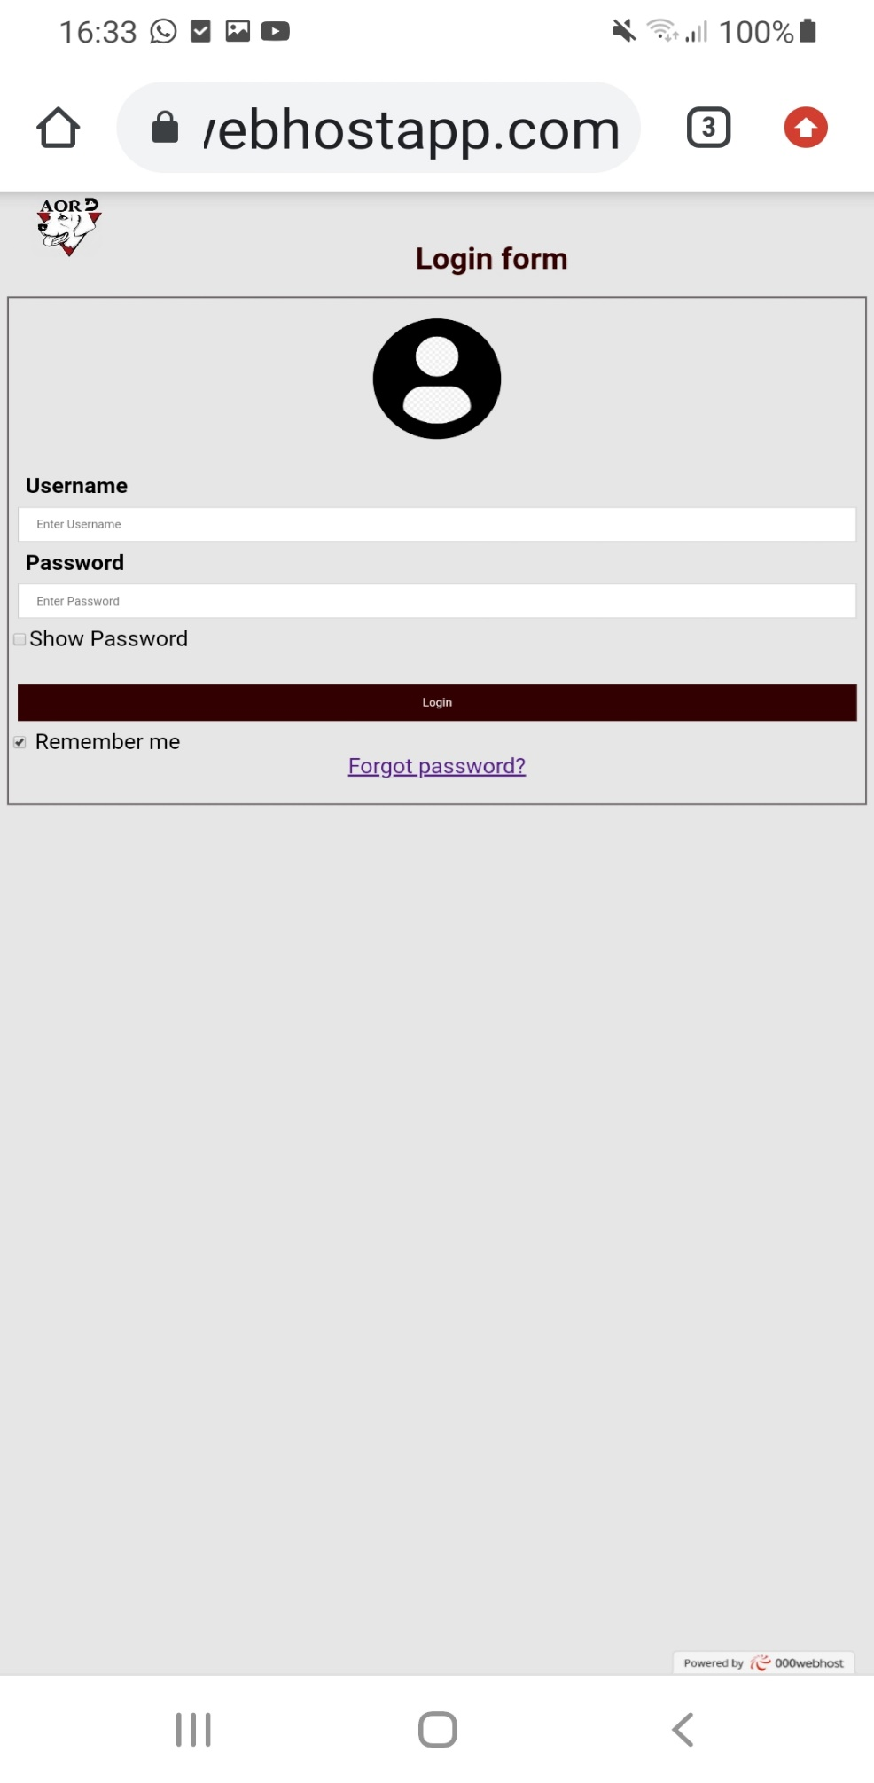

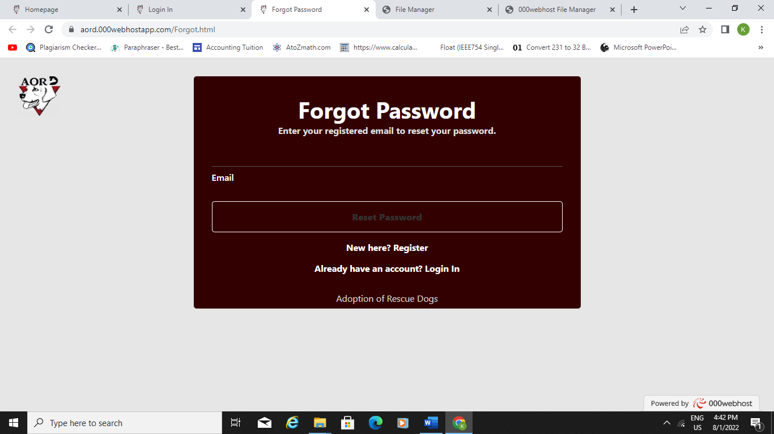**FORM- Forget Password (Forget.html)**

Desktop

Android

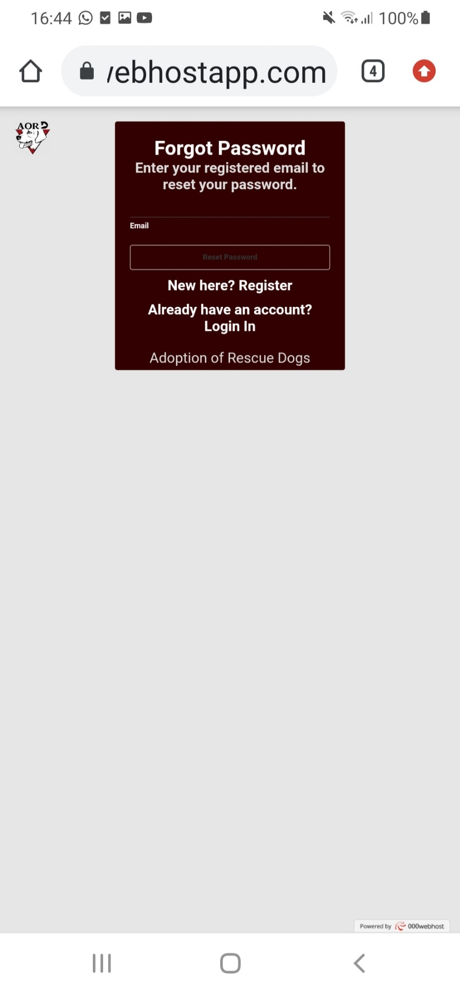

**FORM- Registration (Registration.html)**

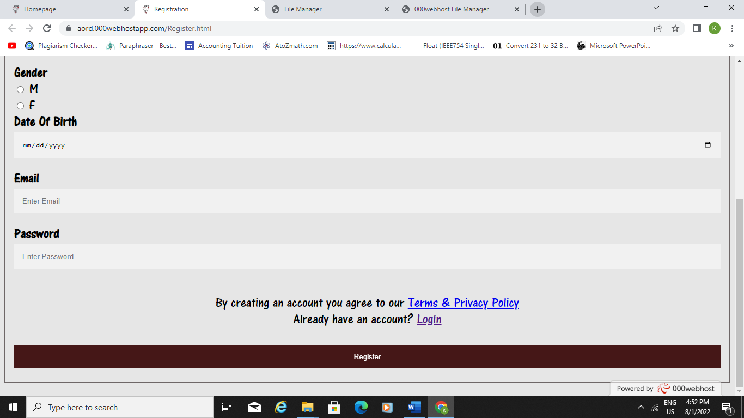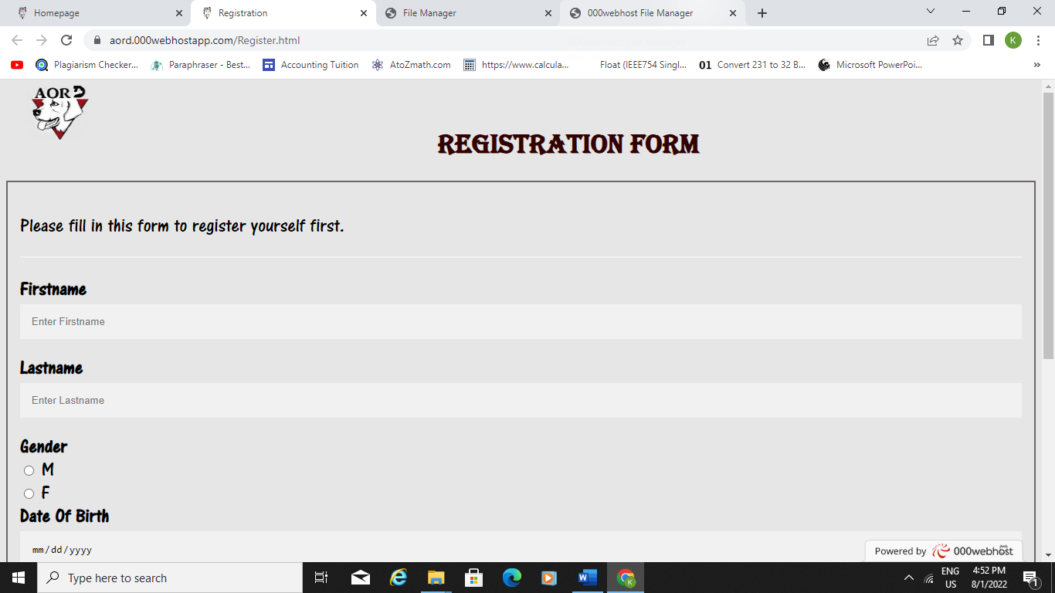Desktop

Android

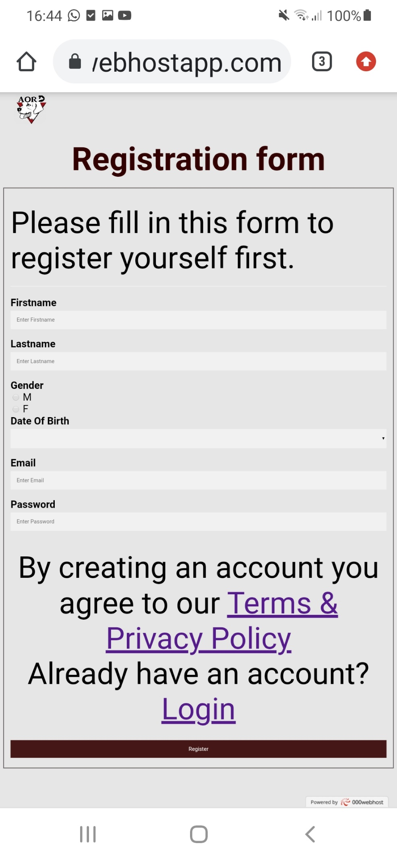

**Adoption and fostering (Adopt.html)**

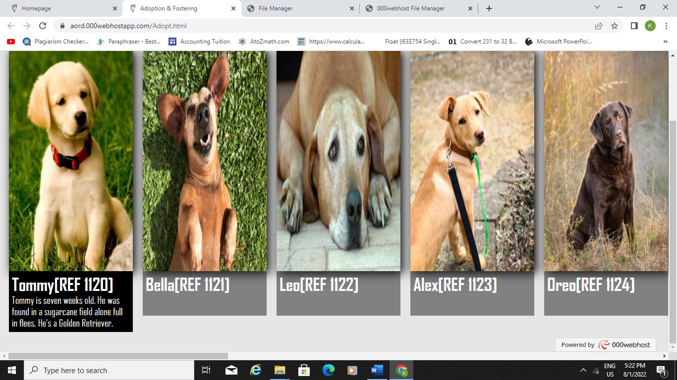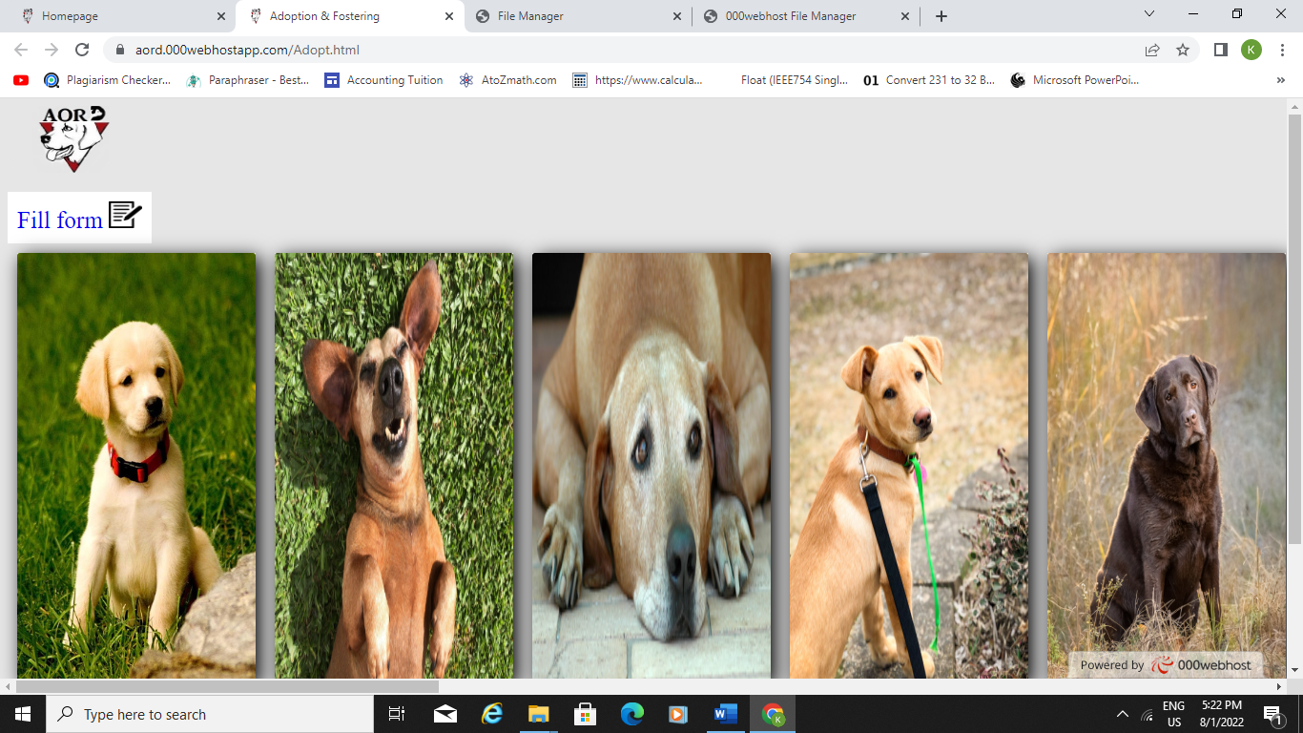Desktop

Android

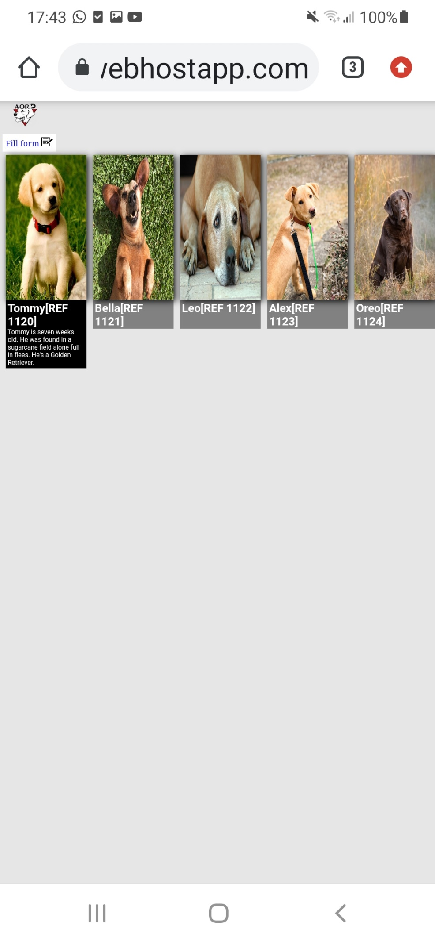

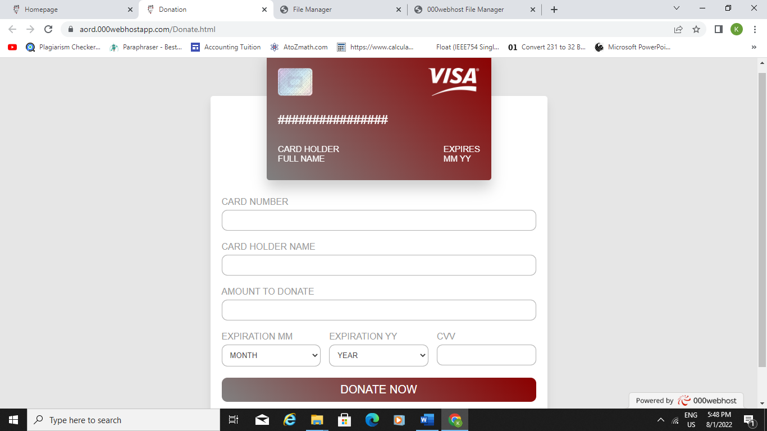**Donation (Donate.html)**

Desktop

Android

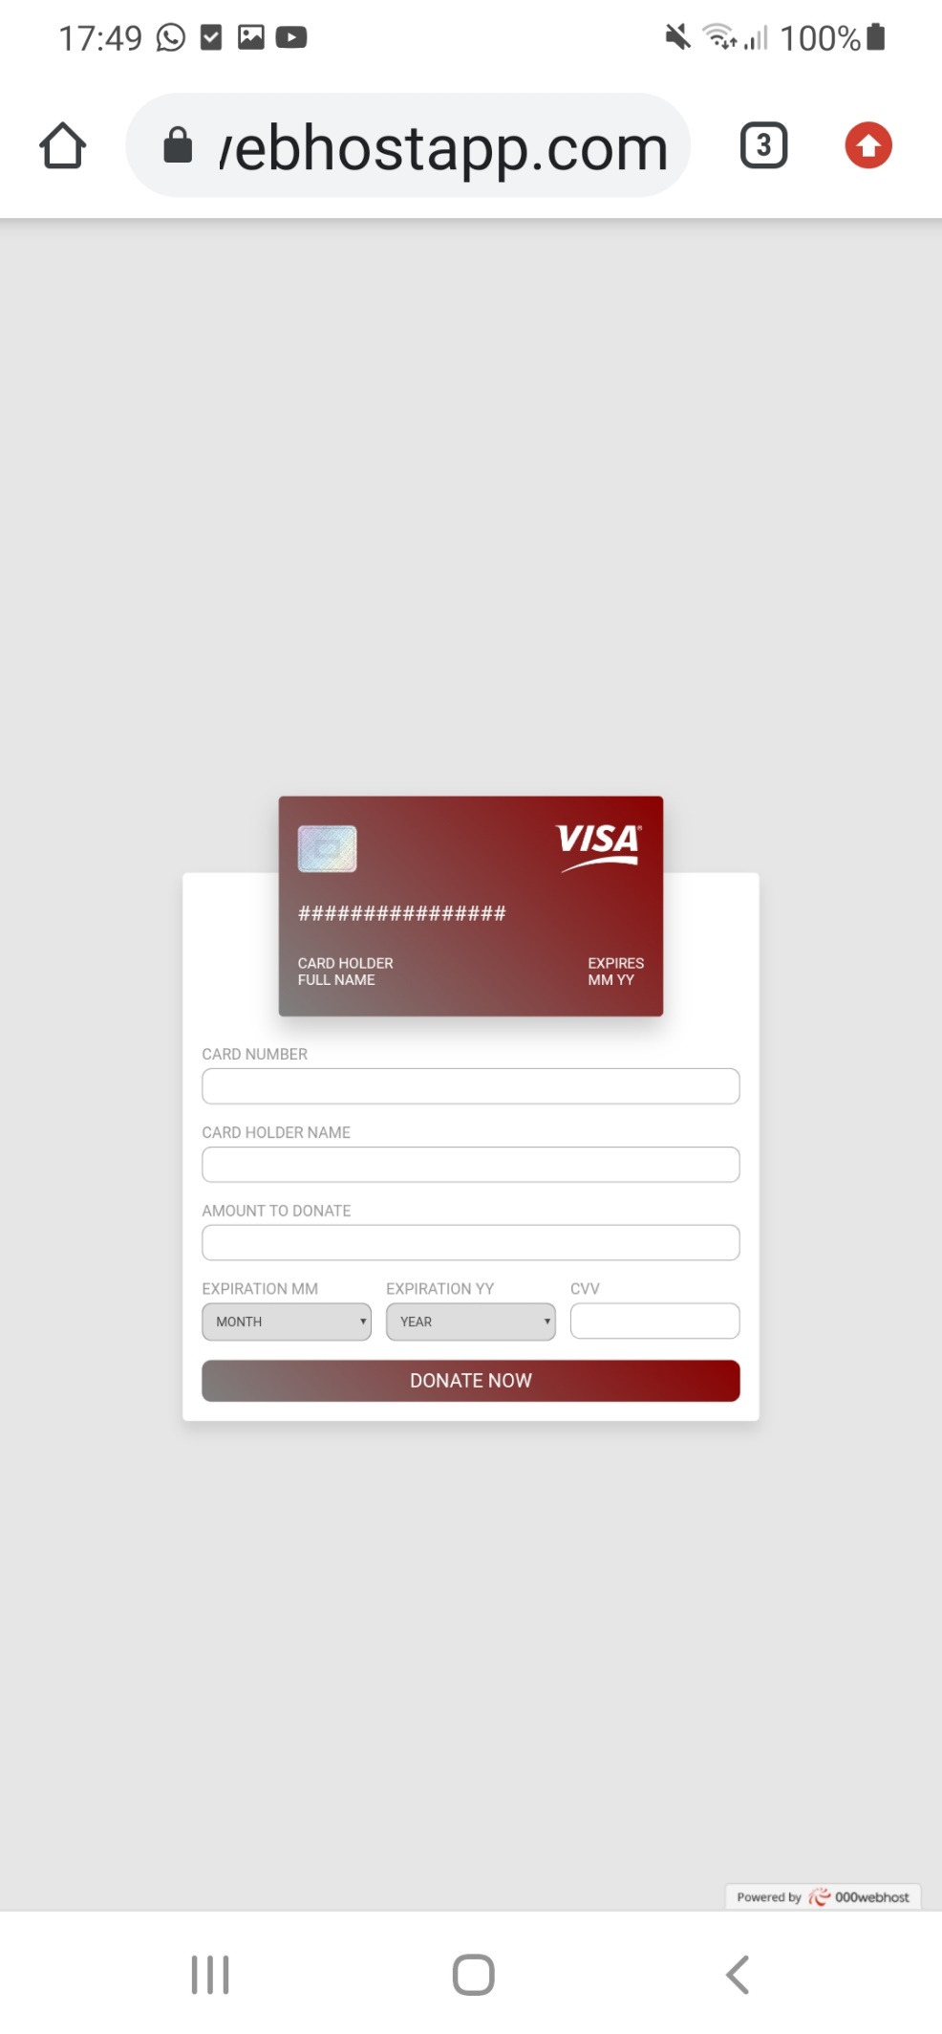

**Event (Event.html)**

Desktop

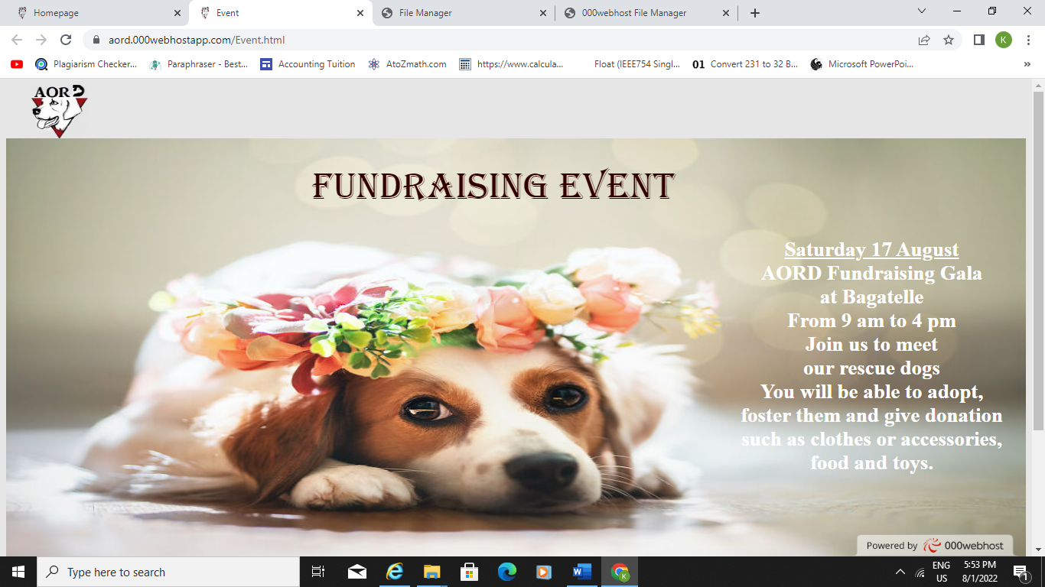

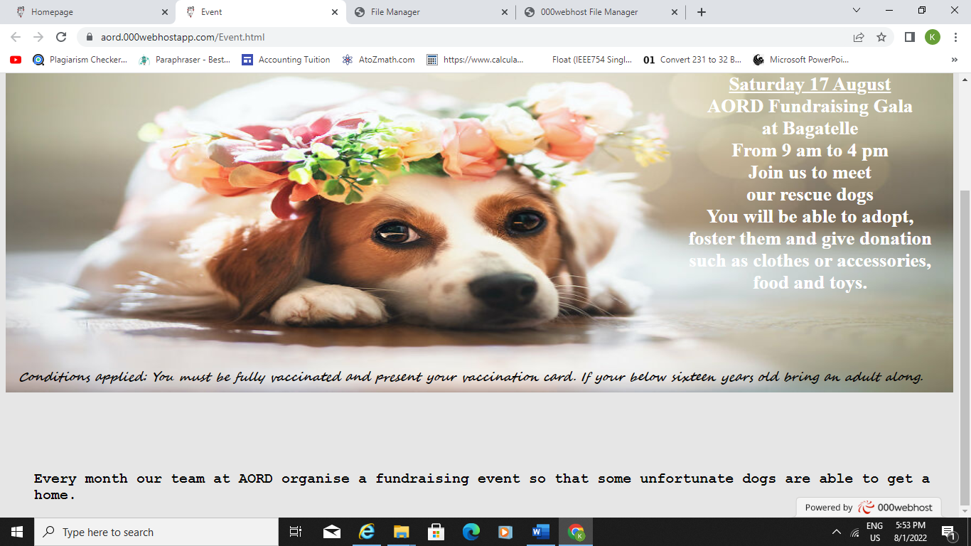

Android

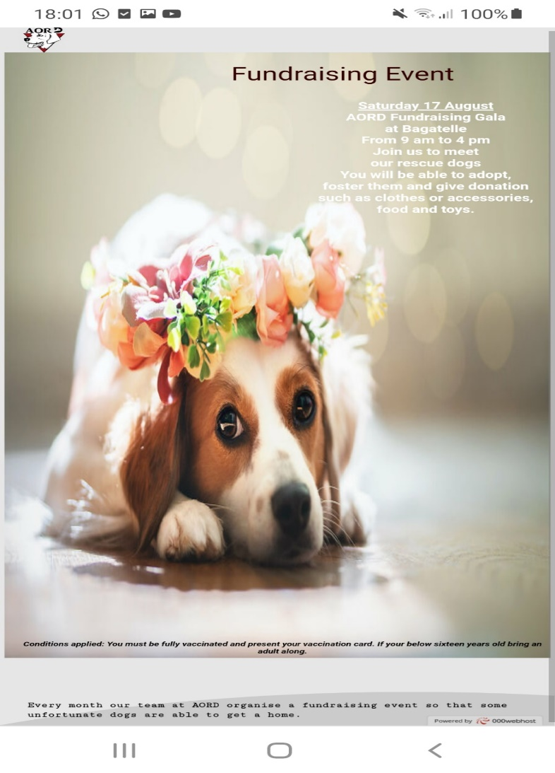

**FORM- Complaint (Complaint.html)**

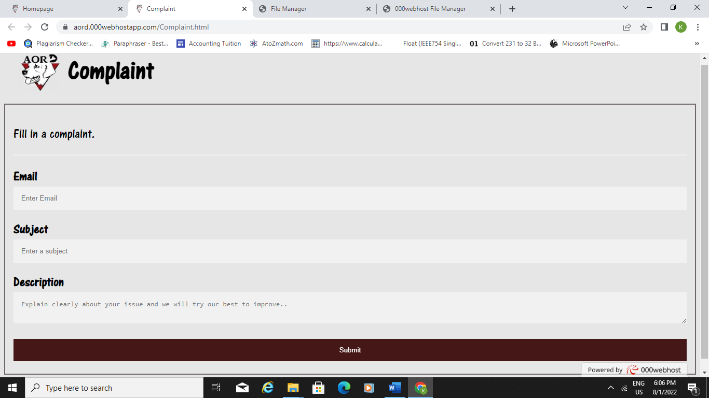Desktop

Android

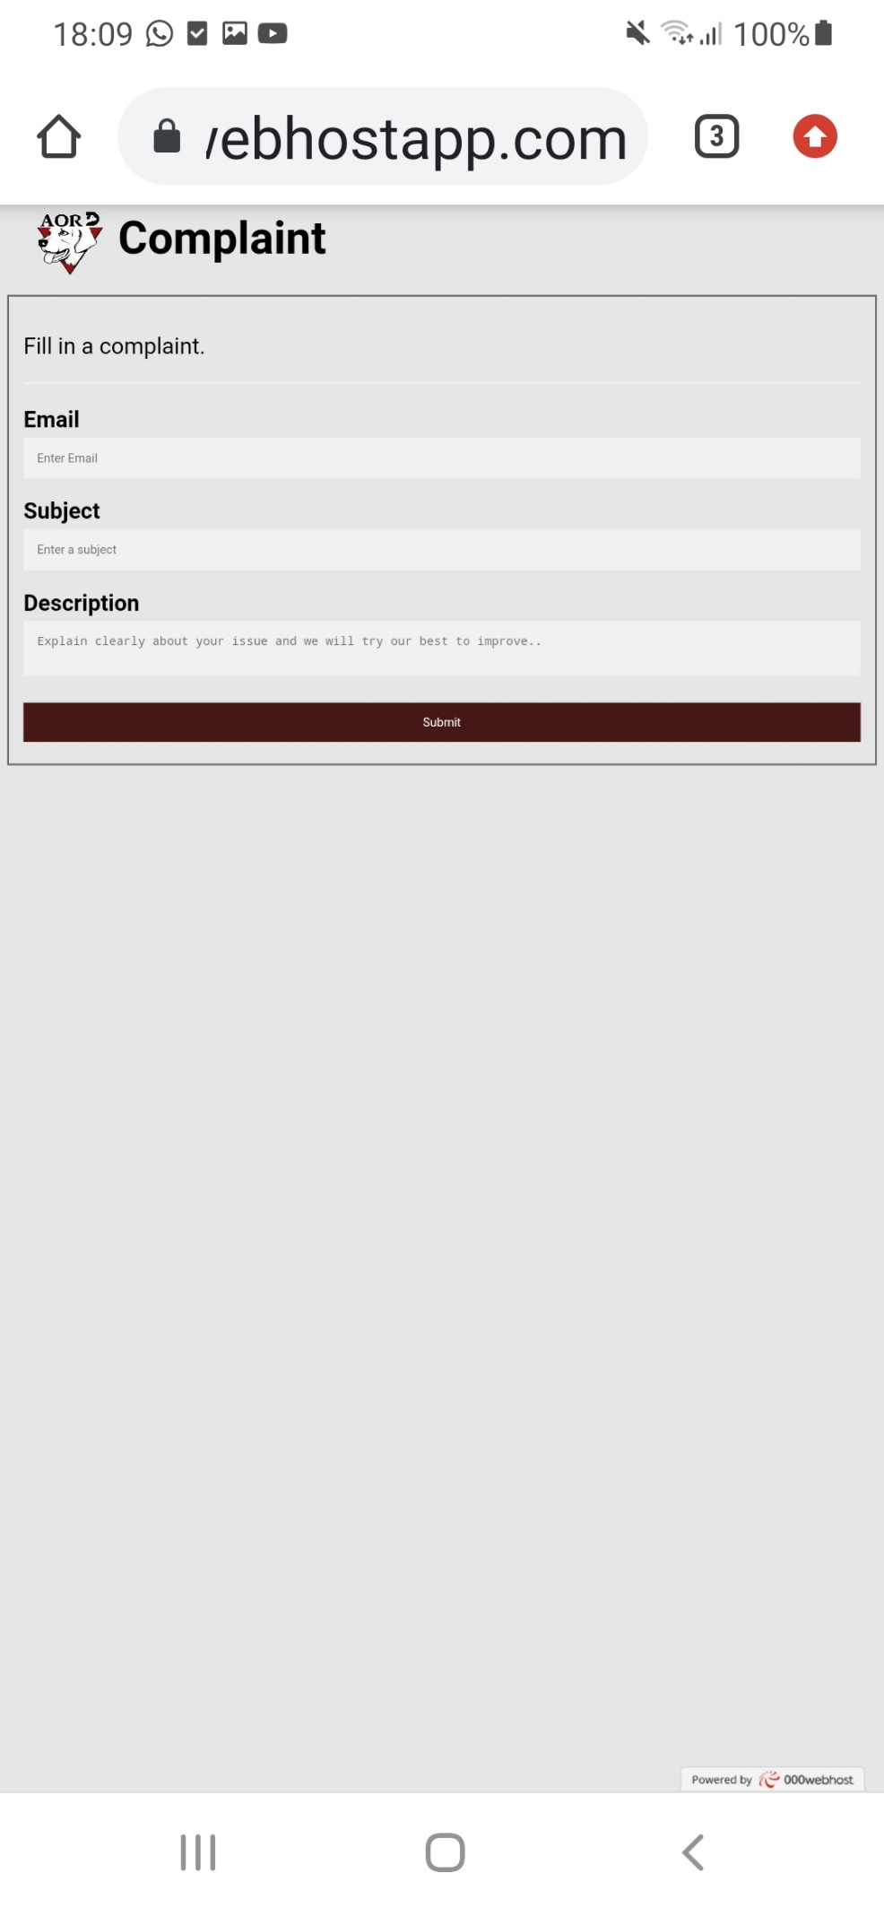

**Feedback (Feedback.html)**

Desktop

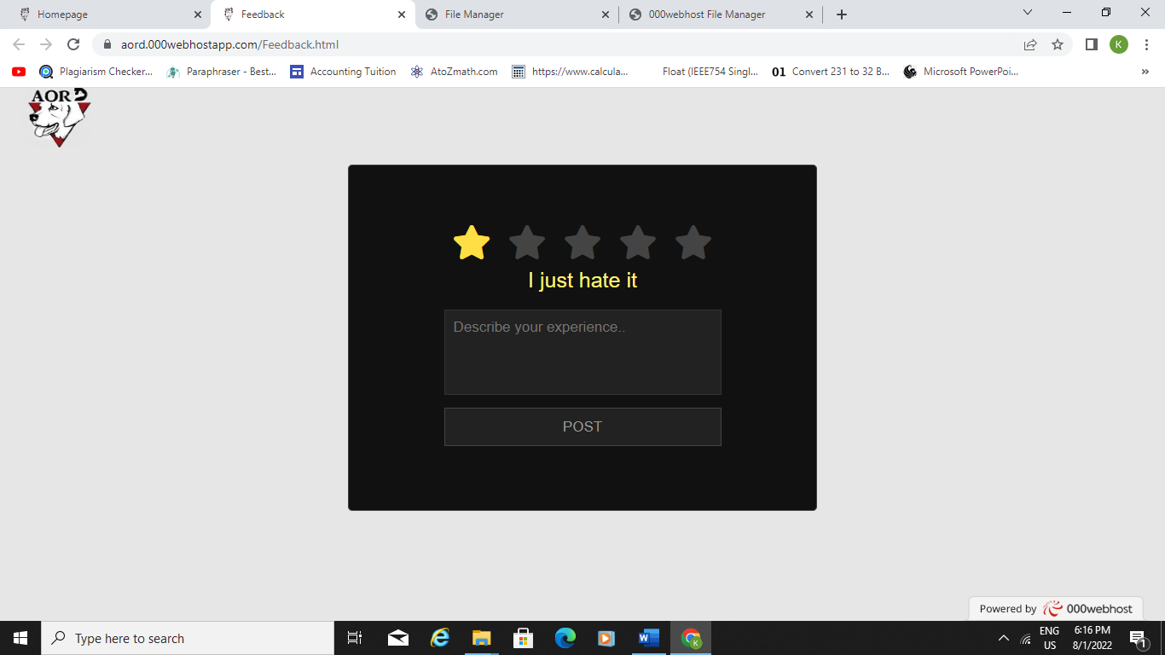

Android

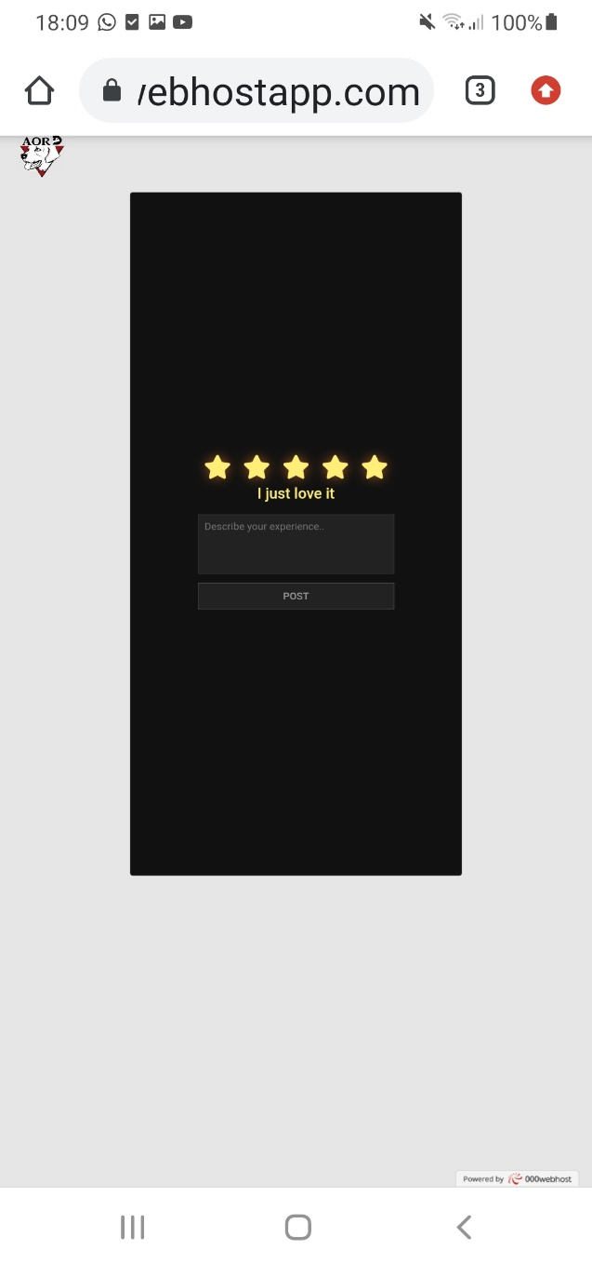

**Social Media- Instagram**

Desktop

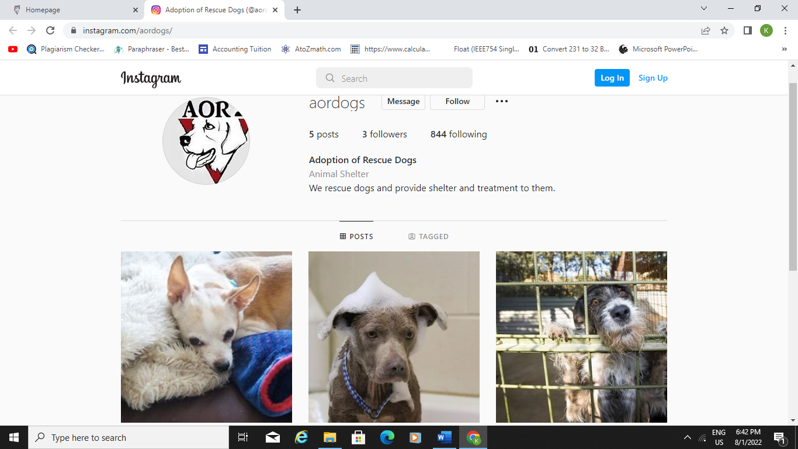

Android

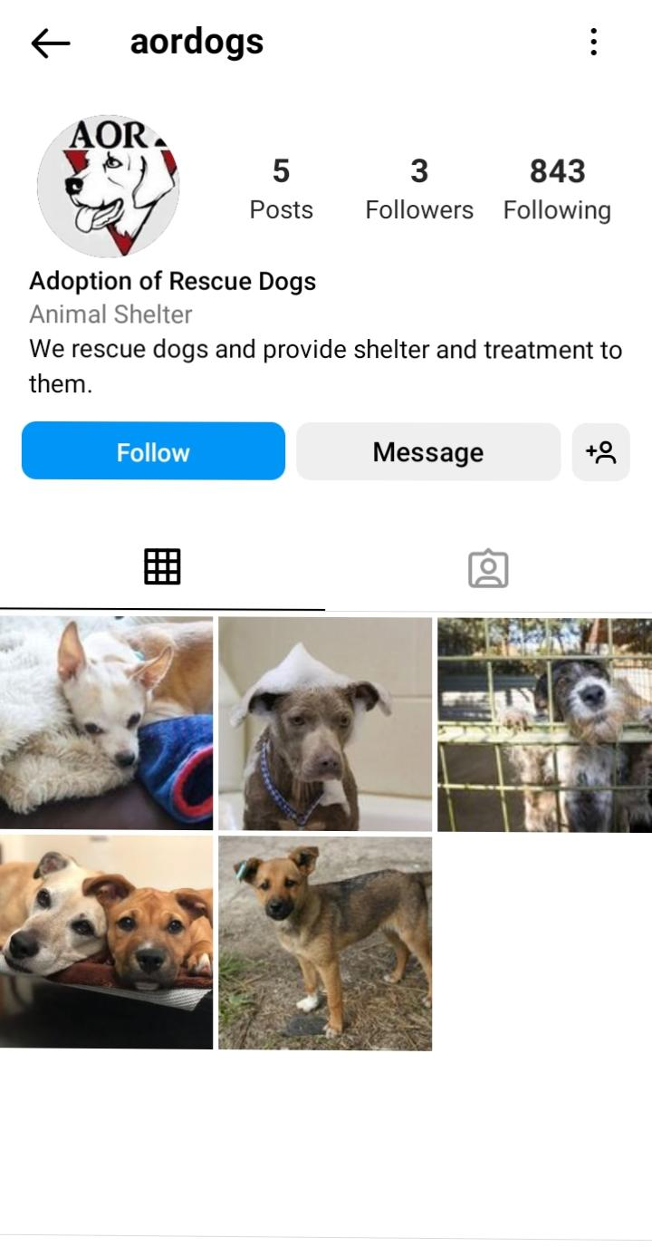

# **ACCESSIBILITY CHECKER (webaccessibility.com)**

